`
Time Frame - 10 weeks (2 weeks per text)
Stage 2

Theme : HEROES

Key Concept : sharing, friendship, courage, bravery, respecting differences.

Texts: Memorial by Gary Crew (picture book), The Incredibles (film), Harry Potter and the Philosophers Stone (novel) and The Avengers Hero Welcome (comic).

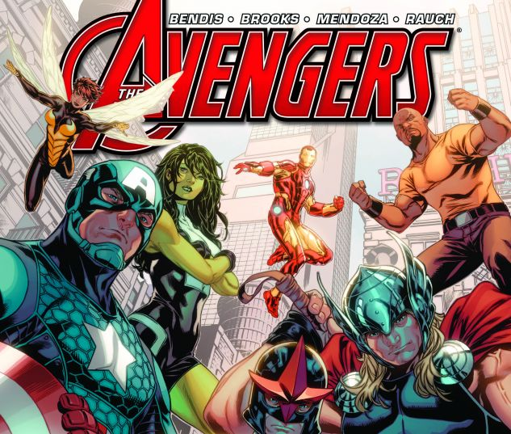
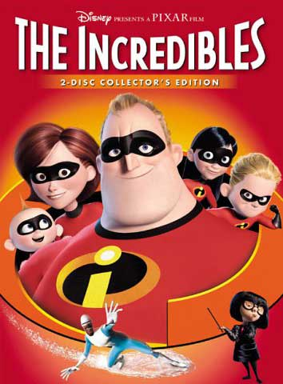
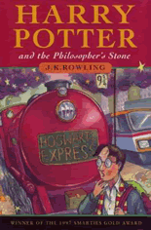
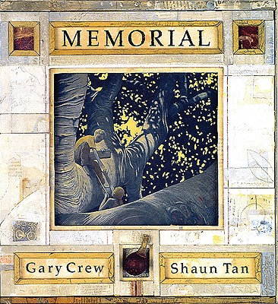

Objective B
Speaking and Listening 2
-discuss ways in which spoken language differs from written language and how spoken language varies according to different audiences, purposes and contexts
-listen to and contribute to conversations and discussions to share information and ideas to negotiate in collaborative ideas
Writing and Representing 2
-uses images in imaginative, informative and persuasive texts to enhance meaning
-understand how audience and purpose influence the choice of vocabulary
-understand how characters, actions and events in imaginative texts can engage the reader
Reading and Viewing 2
-interpret how imaginative, informative and persuasive texts can vary in purpose, structure and topic
-recognise the use of figurative language in texts
Objective A
Speaking and Listening 1
-Interact effectively in groups or pairs, adopting a range of roles
-use information to support and elaborate on a point of view
-respond appropriately to the reading of texts to demonstrate enjoyment and pleasure
Writing and Representing 1
-plan, compose and review imaginative and persuasive texts
-reread and edit texts for meaning, appropriate structure, grammatical choices and punctuation
Reading and Viewing 1
-read different types of texts by combining contextual, semantic, grammatical and phonic knowledge using text processing strategies
-uses strategies to confirm predictions about author intent in imaginative, informative and persuasive texts
-skim a text for overall message and scan for particular info.

Objective E
Reflecting on Learning
-discuss different ways to learn and read
-appreciate how the reader or viewer can enjoy a range of literary experiences through texts
-reflect on own reading and identify the qualities of texts that have contributed to enjoyment of the text
-develop criteria for establishing personal preferences for literature

Objective D
Expressing Themselves
-draw connections between personal experiences and the worlds of texts, and share responses with others
-recognise how aspects of personal perspective influence responses to texts
-consider and discuss ideas drawn from their world and the worlds of their text
-make connections between students’ own experiences and those of characters and events

Objective C
Thinking Imaginatively, Creatively and Interpretively
-share responses to a range of texts and identify features which increase reader enjoyment
-identify creative language features in imaginative, informative and persuasive texts that contribute to enjoyment
-justify interpretations of a text, including responses to characters

Teaching/Learning Activities | Resources | Objectives
Discuss as a class what a hero is (personality, appearance, action)  Brainstorm ideas on the board as a mind map (accept all different examples such as pets, parents, superheroes etc.) and copy into work books. | Work book | EN2-1A
Students write what they think a hero is. Then students visualise their hero (draw) on paper.  Discuss as a class the links between their written description and visual. | Paper/ Work book | EN2-2A
Introduce the story ‘Memories’. Show students the front cover of the book  Discussion:  What is happening in the picture?  Who can you see?  What do the colours represent?  What do you think is going to happen?  Who could be the hero?  Read the first two pages  Discussion:  Who is the old man?  What emotions is he feeling?  What pictures can we see?  Who is in the photos?  What do you notice about the colours?  View the next page of the tree roots  Discussion:  What do the roots represent? (old age)  How long ago was it planted?  Why do we see the roots instead of the whole tree?  Students now predict what the tree is going to look like by drawing a picture of it. Encourage students to use sepia tones. | Memorial by Gary Crew  Work books | EN2-2A  EN2-1A  EN2-4A
Before reading, discuss their predictions of the tree from previous lesson.  Read the next two pages  Discussion:  What is a shrine of remembrance?  When do we most commonly say ‘lest we forget’?  How do the images link to the line ‘he remembers the tiny details but forgets what you might call the picture’?  Who is the statue?  What is the statue for?  Look at the next two pages  Discussion:  What can you see?  How many shadows are there?  Who do the shadows belong to?  Why do we only see the shadows?  Where could this be?  Read the next page and discuss what’s happening in the smaller photos.  Students now imagine they are under the tree and write a descriptive passage explaining what they are doing and how they feel.  For example: ‘5, 4, 3, 2, 1 ready or not here I come!’ I could hear my brother getting closer and closer. The wind was blowing the leaves off the tree. I knew he wouldn’t find me up here. | Memorial by Gary Crew  Work books | EN2-1A  EN2-4A  EN2-7B  EN2-10C
Read the next two pages  Discussion:  What does memorial mean?  What is a memorial service?  Why do we have them?  Look at the next two pages  Discussion:  What does the tree look like? (size, colour, age etc).  As a class, compare the picture of the tree with the ones the students drew earlier. Students are to now draw the tree with the new information they have and publish with their descriptive passage. | Memorial by Gary Crew  Paper | EN2-4A  EN2-10C
Read the next page  Discussion:  Why have things changed?  Why doesn’t he want to remember what happened in Vietnam?  Why doesn’t he want to talk about it?  Turn the page and look at the tree  Discussion:  What emotions does the tree have?  What do you see now?  What does the role in the tree represent?  Read the next 3 pages  Discussion:  Why are both the tree and statue a memorial?  What does the word memorial mean?  Do you think the tree should be cut down?  As a class, first list the reasons why it should be cut down. Then brainstorm why it shouldn’t be cut down. Students then write a letter to the council explaining why they are against it being cut down. | Memorial by Gary Crew  Writing books | EN2-4A  EN2-2A  EN2-7B
Read the next page  Discussion:  What do you notice about the background? (cracks)  What is happening to the nature?  Turn the page  Discussion:  What do you see?  What are the leaves doing?  How does the unknown soldier feel?  How do we know?  Read then next page  Why are memories important?  Why are they ‘ever-livin’ things’?  What does the image of the boy show us?  Read the last page  What do you see in the background?  Will the statue last forever?  What will last forever?  To finish the book students write down what made grandpa a hero. | Memorial by Gary Crew  Paper | EN2-4A
As a class, revisit the mind map created in the first lesson. Students are encouraged to add more examples of heroes to this mind map. | Work book | EN2-8B
Display the comic ‘Heroes Welcome’ cover to the class. Discuss what we can see on the cover, who are the characters? Predict what you think the story is about?  Read the first two pages and as a class discuss the teacher’s comments.  Are they just people in funny outfits looking for attention?  Are they causing more harm then good (collateral damage)?  Are the only real heroes the people who are attempting to cure disease and homelessness?  Students write a paragraph in their books writing if they agree or disagree with Mr. Alligood, and why? | The Avengers “Heroes Welcome” | EN2-4A
Read pages 3 and 4. Discuss how Nova is feeling.  Why does he feel this way?  What do you think is Nova’s tone while he is talking?  How does the illustrator convey this?  Is Nova friends with the Avengers?  Why do you think Nova went to them?  What is a role model?  Why would wearing a costume be cowardly?  Students write a paragraph pretending to be one of the Avengers, Answering Nova’s questions. (Predict what the Avengers response will be)  Extension: students write a different answer for each Avenger, they each have different personalities will they give different answers? Will they be sympathetic or blunt with Nova? | The Avengers “Heroes Welcome” | EN2-4A
Read pages 5,6,7  Is the world a better place because of them?  What does Captain America mean when he says “It will never be enough”?  What does it mean when Cage says “People have to fight their own battles”?  Why haven’t they “destroyed each other” and why is that ‘amazing”  Why does Captain America say Uniforms not costumes?  As a class discuss all the characters costumes/uniforms and what they represent.  Students draw a uniform based on themselves, using symbols or colors that represent their qualities or personality. | The Avengers “Heroes Welcome” | EN2-4A
Read the rest of the comic  What is a selfless act?  Who is the hero in this story? (The Avengers for mentoring and being a good friend to Nova)  Why was Nova upset?  Was Nova a hero the entire time  What is a hero? Has your perception changed?  Student will answer this question in their books. When have you been a hero? | The Avengers “Heroes Welcome” | EN2-4A
As a class, revisit the mind map created in the first lesson. Students are encouraged to add more examples of heroes to this mind map. | Work book | EN2-8B
Display the book ‘Harry Potter and the Philosophers Stone.’ Read Chapter 2 of the book  What qualities of a hero does Harry show in this chapter?  How do Harry and his Aunt and Uncle converse?  How does Harry deal with this adversity?  In their work books, students rule a line down the middle of their page and write the similarities and differences between Harry’s life and their own lives. To demonstrate that Harry’s life isn’t all that different from ours (Apart from his aunt and uncle). | Harry Potter and the Philosophers Stone
Read Chapter 5 of the book  Is Harry ordinary anymore?  How has he changed?  How does Harry know he is different? | Harry Potter and the Philosophers Stone
Read Chapter 10 of the book  Who is the Hero in the troll sequence?  What heroic qualities did they show?  Who was more heroic, Ron or Harry?  In many texts a hero saves a friend or one of their peers. Students will write a summary of this chapter then write a summary of another movie/book/TV show they have seen that has a hero saving someone. | Harry Potter and the Philosophers Stone
Read half of Chapter 16 of the book  Who is the Hero in the room with “Devil’s Snare”?  Who is the Hero in the room with the flying keys?  Who is the Hero in the room with the chess?  Students write in their work books what heroic qualities the three heroes used to beat their room and why that person was the only person who could have passed that room. For example Hermione used her intelligence to defeat the devils snare because she is the smartest of the three and got the information from a book she has read | Harry Potter and the Philosophers Stone
Continue Chapter 16 of the book  Discuss who is the biggest hero in the chapter?  Could the group have progressed if Hermione or Ron wasn’t there?  Discuss the importance of working as a team?  Students write a character profile of the three heroes, writing each character’s strengths and weaknesses. | Harry Potter and the Philosophers Stone
As a class, revisit the mind map created in the first lesson. Students are encouraged to add more examples of heroes to this mind map. | Work book | EN2-8B
As a class discuss what traits a hero has.  e.g. friendship, bravery, strength (mental/physical), respectful, integrity, leadership, role model, loyal, forgiving, dedicated etc.  Watch the first 27 minutes of the movie  - Who wants the pressure of being “super” all the time?  - 7:20 buddy walks up to the vault cover and there is a reflection of him, how does this reflect his personality?  - Is Buddy a super hero, why/why not?  - Why did Mr. Incredible and Elastagirl pretend to no know each other on the rooftop?  - What does suing mean?  - Why were the people suing the superhero’s?  - Why did Mr Incredible have to quit being a superhero?  - Why do you think the creator choose to give Mr Incredible a office/desk job?  - Why is Mr Incredible helping the old woman, why is he whispering and looking around?  - Why is Mr Incredible’s boss angry?  - Whats the difference between the ways Dash uses his powers and how his parents used their abilities?  - Why isn’t Dash allowed to play sports?  - Why is Mr Incredible angry with the car, is it because it is broken or is there another reason?  - Why does Violet want to be “Normal”  - Why did Mr Incredible lie about “Going bowling”  - How do the policeman act with the “Robbers” (Mr Incredible and Frozen), how is this different from how the superheros deal with robbers?  - Why is Mr Incredible angry and what does he mean by “finding new ways to celebrate mediocrity”  - Finish Mr Incredibles Sentence “find new ways to celebrate mediocrity but if someone is exceptional they…”  As a class create character profiles of the entire family, write about their appearance, abilities and personalities.  Extension question: How are the incredibles just like a normal family? | The Incredibles | EN2-8B  EN2-10C
Watch the movie from 25:00-49:00  - Pause the frame where Mr Incredible is typing at his desk, What can you see, how does the director try to make is seem like Mr Incredible is bored or how his work is boring (boring colours, quiet sound, nothing personal on the desk, body language hunched over, tired eyes, tone of voice from receptionist)  - Why did the director choose to make the Boss really short? What do we know about the boss’ personality?  - What’s the difference between Mr Incredibles home desk and his boss’ desk  - Why does the director show Mr. incredible stretching and looking like he’s put on weight?  - How is is suit for dinner different to his work suit? (white and black, compared to the red tie red meaning power)  - Why is Mr Incredible happy with his family now? | The Incredibles | EN2-8B  EN2-10C
Watch the movie from 50:00-1:15:00  - Pause at 50:00 in the conference room, why did the director choose these colours, why did he choose those chairs, how does that room make you feel and why?  - Why is Syndrome mad at Mr. Incredible?  - Why couldn’t Violet put a forcefield around the plane? Does this mean she is not a hero?  - In the scene where Mr incredible grabs Mirage and threatens to crush her, what does Syndrome do to show that he isn’t a hero and what does Mr incredible do to show he is a hero?  - When Mr Incredible lets mirage go does that mean he is weak?  - What is the symbolism off when Elastagirl is being the boat (She’s carrying the family on her shoulders, working together as a family)  - Why is it a big moment for violet when she puts on the mask?  Students create a profile of Syndrome and answer the question; Is syndrome a superhero? Why/why not? | The Incredibles | EN2-8B  EN2-10C
Watch the movie from 1:15:00-1:50:00  - Why does Mirage let Mr Incredible go?  - Elastagirl saves Mr incredible from the jail does that mean she is a bigger hero? Why is this different from past superhero movies?  - What does it mean by “If everyone is super, then no one will be”?  - Why does Mr Incredible want to work alone and not with his family?  - Mr Incredible is scared, does this mean he is not a hero? Can heroes be scared?  - If the robot had good intentions would it be a hero? Or would the creator be a hero?  Students revisit their character profiles from the first lesson and create a new subheading for how the characters changed. Students write how each character changed from the start of the movie. | The Incredibles | EN2-8B  EN2-10C
To conclude the unit, students will write what they believe a hero is. They then visualise on paper what their hero looks like. Once students have completed this, they will compare their work with their completed activity from week 1.  Have a class discussion on the similarities and differences in their responses from week 1 and week 10. | Paper/ Work book | EN2-2A  EN2-1A

