[](http://r18.cooltext.com/d.php?renderid=748867198&extension=png)[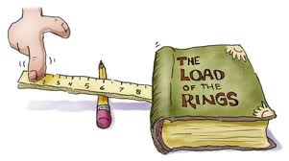](http://www.google.com.au/imgres?q=simple+machines&um=1&hl=en&safe=active&sa=N&biw=1280&bih=796&tbm=isch&tbnid=gtOCFa_YhJwqgM:&imgrefurl=http://dogfoose.com/infotoons/&docid=14XQZFVvTiUdqM&imgurl=http://dogfoose.files.wordpress.com/2008/10/18-simple-machines.jpg&w=600&h=335&ei=wTA4UOvOMYqRiQfrqYHIBQ&zoom=1&iact=hc&vpx=837&vpy=456&dur=1219&hovh=168&hovw=301&tx=151&ty=93&sig=113232778000319547130&page=1&tbnh=106&tbnw=190&start=0&ndsp=24&ved=1t:429,r:16,s:0,i:121)

What is a machine? ___________________________________________

__________________________________________________________

Cut and paste examples of each simple machine to the correct box. Draw an example of that simple machine under that picture.

Screw

Draw

Inclined Plane

Draw

Wedge

Draw

Pulley

Draw

Wheels

Draw

Levers

Draw

You are a zoo keeper and Tang Mo the elephant is sick and can’t walk. Tang Mo needs to be moved to another zoo to get better. What simple machines would you use to move her? Write or draw and label your answers.



[](http://www.google.com.au/imgres?q=thinking&um=1&hl=en&safe=active&sa=N&biw=1280&bih=796&tbm=isch&tbnid=Uf-x6yL4Uq6RQM:&imgrefurl=http://cms.montgomerycollege.edu/edu/department.aspx?id=22319&docid=DMWOzN9FHZ5B0M&imgurl=http://cms.montgomerycollege.edu/uploadedImages/EDU/Departments_-_Academic/Writing,_Reading,_and_Language_Center_-_R/Picture1%20for%20Thinking%20Thursdays.png&w=463&h=628&ei=ly84UKWMLo6biQeYlID4Ag&zoom=1&iact=hc&vpx=173&vpy=234&dur=984&hovh=262&hovw=193&tx=108&ty=142&sig=113232778000319547130&page=1&tbnh=138&tbnw=102&start=0&ndsp=28&ved=1t:429,r:7,s:0,i:93)

[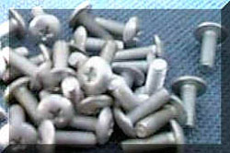](http://www.mikids.com/SMachinesScrews.htm)

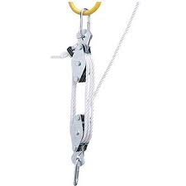[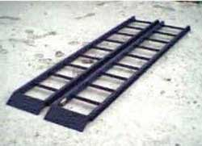](http://www.mikids.com/SMachinesInclinedPlanes.htm)

[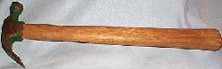](http://www.mikids.com/SMachinesLevers.htm)

[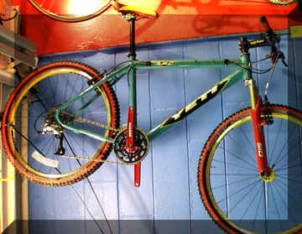](http://www.mikids.com/SMachinesWheels.htm)

[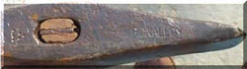](http://www.mikids.com/SMachinesWedges.htm)

[](http://www.mikids.com/SMachinesScrews.htm)

[](http://www.mikids.com/SMachinesInclinedPlanes.htm)

[](http://www.mikids.com/SMachinesLevers.htm)

[](http://www.mikids.com/SMachinesWheels.htm)

[](http://www.mikids.com/SMachinesWedges.htm)

[](http://www.mikids.com/SMachinesScrews.htm)

[](http://www.mikids.com/SMachinesInclinedPlanes.htm)

[](http://www.mikids.com/SMachinesLevers.htm)

[](http://www.mikids.com/SMachinesWheels.htm)

[](http://www.mikids.com/SMachinesWedges.htm)