`
Time Frame - 10 weeks (2 weeks per text)
Stage 2

Theme : Magic

Key Concept : Visual Representation, Emotive Language, Figurative Language, Words/Images

Text Set – Old Ridley by Gary Crew (picture book), The Viewer by Gary Crew (picture book), The Magic Finger by Roald Dahl (novel), Willy Wonka and the Chocolate Factory (film).

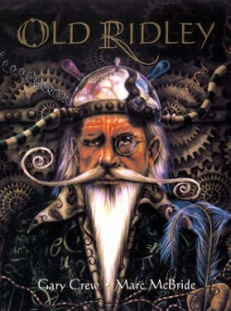
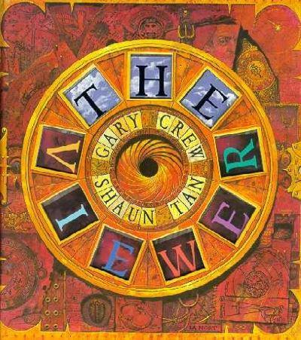
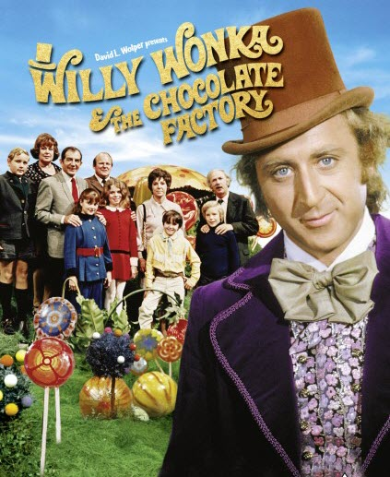
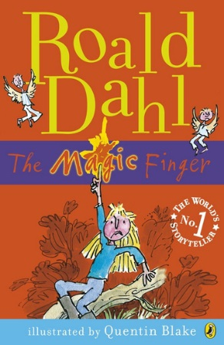

Objective A
Speaking and Listening 1
-Interact effectively in groups or pairs, adopting a range of roles
-use information to support and elaborate on a point of view
-respond appropriately to the reading of texts to demonstrate enjoyment and pleasure
Writing and Representing 1
-plan. Compose and review imaginative and persuasive texts
-reread and edit texts for meaning, appropriate structure, grammatical choices and punctuation
Reading and Viewing 1
-read different types of texts by combining contextual, semantic, grammatical and phonic knowledge using text processing strategies
-uses strategies to confirm predictions about author intent in imaginative, informative and persuasive texts
Objective B
Speaking and Listening 2
-discuss ways in which spoken language differs from written language and how spoken language varies according to different audiences, purposes and contexts
-listen to and contribute to conversations and discussions to share information and ideas to negotiate in collaborative ideas
Writing and Representing 2
-understand how a range of language features can shape readers’ and viewers understanding of subject matter
-use images in imaginative, informative and persuasive texts to enhance meaning
-understand how audience and purpose influence the choice of vocabulary
Reading and Viewing 2
-interpret how imaginative, informative and persuasive texts can vary in purpose, structure and topic
-recognise the use of figurative language in texts
Grammar, Punctuation and Vocabulary
-understand that choice of vocabulary impacts of the effectiveness of roles

Objective E
Reflecting on Learning
-discuss different ways to learn and read
-appreciate how the reader or viewer can enjoy a range of literary experiences through texts
-reflect on own reading and identify the qualities of texts that have contributed to enjoyment of the text
-develop criteria for establishing personal preferences for literature
Objective D
Expressing Themselves
-draw connections between personal experiences and the worlds of texts, and share responses with others
-recognise how aspects of personal perspective influence responses to texts
-consider and discuss ideas drawn from their world and the worlds of their text
-make connections between students’ own experiences and those of characters and events
Objective C
Thinking Imaginatively, Creatively and Interpretively
-share responses to a range of texts and identify features which increase reader enjoyment
-identify creative language features in imaginative, informative and persuasive texts that contribute to enjoyment
-justify interpretations of a text, including responses to characters

Teaching/Learning Activities | Resources | Objectives
Display the book to the students. Discuss the front cover of the book as a class.  What can you see?  Who is the character?  Is he happy or sad?  Is he young or old?  What is his job?  Students then write a paragraph about who they believe Old Ridley is. | Old Ridley by Gary Crew  Paper/Work book | - EN2-7B
Read first few pages to the students. Have a class discussion on the meaning and relevance of adjectives and this link with images. For example on the first page “Everything about the place fascinated him: its weathered shingles, its twisted chimneys, its towers and turrets, its cobwebbed arches.” Discuss the links between these adjectives and the images on the page. | Old Ridley by Gary Crew | - EN2-9B
Continue to read the remaining part of the story to the students. Provide students with a cloze passage from the text. Students must complete the cloze passage by writing their own adjectives in the blank spaces. Students are encouraged to use the images from the text to choose relevant adjectives. | Old Ridley by Gary Crew  Cloze passage from text | - EN2-9B
Revisit the last few pages of the story. Lead discussion on whether or not Old Ridley was really an inventor. Students must then write a paragraph with supporting evidence justifying whether or not he was an inventor or not. | Old Ridley by Gary Crew | - EN2-7B
ASSESSMENT  Students complete an artwork inspired by the stained glass windows in the story. Each student will create their own square to display on the window (all put together to make one large window). Students will choose one of the gods (Eos or Cithonus) to feature on their artwork. | Old Ridley by Gary Crew  Cellophane, paper, scissors, glue | - EN2-10C
Read The Magic Finger (stop at page 10). Discuss with students what the magic power is and how it works. Brainstorm as a class different magic powers. Students then visualise on paper their own magic power. | The Magic Finger  Paper/Work book | - EN2-10C
Read The Magic Finger (stop at page 35). Discuss what elements of magic have happened in the story so far. As a class, discuss whether or not magic should be used for good or evil. Students then write how they would use their power for good and evil. Share responses with the class. | The Magic Finger  Paper/ Work book | - EN2-7B
Read remainder of story. As a class, write a limerick based on The Magic Finger. Students then write a limerick of their own magic power. Share limericks with the class. | The Magic Finger  Paper/Work book | - EN2-2A
Read text till the end of page 3. Ask students to list what they believe is in the curious box. Once they have completed their list, students will then draw their curious box (revisit later). | The Viewer  Paper/Work book | - EN2-2A
Throughout reading the story, the class will have ongoing discussions about the viewfinders (teacher discretion to be used with which viewfinders to discuss in more detail). | The Viewer | - EN2-1A
As a class, the students will create a viewfinder on the whiteboard of significant events at school that have occurred throughout the year. Students will then create their own viewfinder of their life timeline independently. | The Viewer  Paper/Work book | - EN2-10C
As a class, revisit the curious box. Discuss what students believed was in the curious box and what in fact was in there. Students will then discuss what items from home they would have in their own curious box (items that link with their viewfinder). Students will create their own curious box at home and bring it in to present to the class | The Viewer | - EN2-10C
Students will present a talk on their viewfinder timeline and present their curious box. There should be a direct link between the two evident. | The Viewer  Curious Box | - EN2-1A
ASSESSMENT  Students will write a few paragraphs answering the question “What element in the story ‘The Viewer’ is magic?” | Assessment Paper | - EN2-7B
Watch the movie ‘Willy Wonka and the Chocolate Factory (stop just before they enter the factory). Discuss the different cultures and lifestyles that are evident in the children chosen to enter the factory. Students will write a paragraph from their chosen characters point of view about how they are feeling and what they want to do when they get inside the factory. Share responses with the class. | Willy Wonka and the Chocolate Factory DVD | - EN2-1A  - EN2-2A
Continue to watch the movie. While viewing, students must list all the fantasy elements they see. | Willy Wonka and the Chocolate Factory DVD | - EN2-4A
Continue to watch the movie. Students will use visual representations to represent the ideas of fantasy elements. Teachers discretion as to whether or not this is presented through a  - Picture book  - PPT  - Comic strip  - Storyboard | Willy Wonka and the Chocolate Factory DVD | - EN2-10C
Finish watching the movie. Using scripts from the movie, students will act out a scene from the movie. | Willy Wonka and the Chocolate Factory DVD  Scripts | - EN2-11D
ASSESSMENT  Students will create a project cube to then display in the classroom. Each side of the cube will represent a text (Old Ridley, The Magic Finger, The Viewer and Willy Wonka and the Chocolate Factory). Each side must have an element of magic from each book. | Project Cube | - EN2-10C

