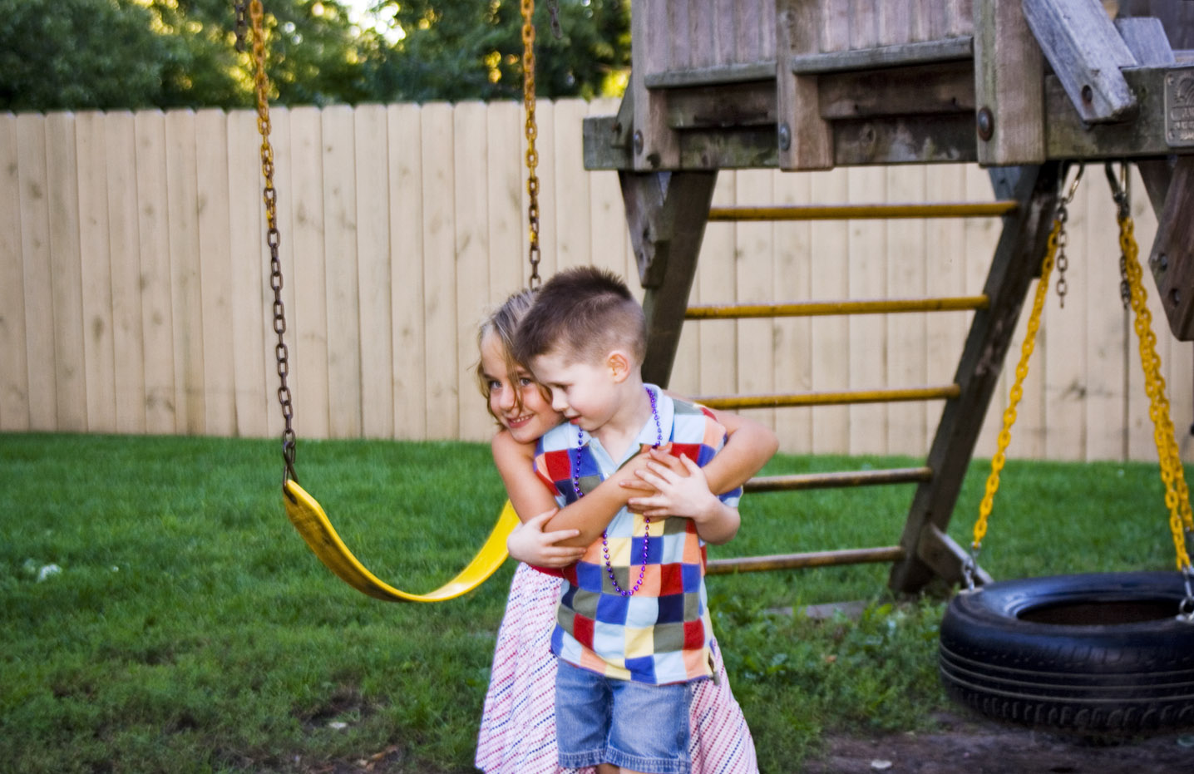
Stage Stage 2

Time Frame 10 weeks

Theme Belonging

Key Concepts
- Culture
- Characterisation
- Stereotypes
- Point of View

Students will gain an understanding, acceptance and empathy for others who may be different from them in a variety of social settings. They will respond to ideas and characters in texts, their experiences and relationships.

Objective A  Communicate through speaking, listening, reading, writing, viewing and representing. | Objective B  Use language to shape and make meaning according to purpose, audience and context. | Objective C  Think in ways that are imaginative, creative, interpretive and critical. | Objective D  Express themselves and their relationships with others and their world. | Objective E  Learn and reflect on their learning through their study of English.
Speaking and Listening 1  EN2-1A communicates in a range of informal and formal contexts by adopting a range of roles in group, classroom, school and community contexts.  - Develop & apply contextual knowledge  - Understand & apply knowledge of language forms and features  - Respond to & compose texts  Writing & Representing 1  EN2-2A plans, composes and reviews a range of texts that are more demanding in terms of topic, audience and language  Develop & apply contextual knowledge  - Understand & apply contextual knowledge  - Respond to & compose texts  H’writing & Digital Technologies  EN2-3A uses effective handwriting and publishes texts using digital technologies  - Develop & apply contextual knowledge  - Understand and apply knowledge of language forms and features  - Respond to & compose texts  Reading & Viewing1  EN2-4A uses an increasing range of skills, strategies and knowledge to fluently read, view and comprehend a range of texts on increasingly challenging topics in different media and technologies  - Develop & apply contextual knowledge  - Understand & apply knowledge of language forms and features  - Develop and apply phonemic knowledge  - Respond to and view texts  Spelling  EN2-5A uses a range of strategies, including knowledge of letter sound correspondences and common letter patterns, to spell familiar and some unfamiliar words  - Develop & apply contextual knowledge  - Understand & apply contextual knowledge  - Respond to & compose texts | Speaking and Listening 2  EN2-6B identifies the effect of purpose and audience on spoken texts, distinguishes between different forms of English and identifies organisational patterns and.  - Develop & apply contextual knowledge  - Understand & apply knowledge of language forms and features  - Respond to & compose text  Writing & Representing 2  EN2-7B identifies and uses language forms and features in their own writing appropriate to a range of purposes, audiences and contexts.  - Develop & apply contextual knowledge  - Understand & apply knowledge of language forms and features  - Respond to & compose texts  Reading & Viewing 2  EN2-8B identifies and compares different kinds of texts when reading and viewing and shows an understanding of purpose, audience and subject matter  - Develop & apply contextual knowledge  - Understand & apply contextual knowledge of language forms and features  - Respond to, read & view texts  Grammar, Punctuation & Vocab  EN2-9B uses effective and accurate sentence structure, grammatical features, punctuation conventions and vocabulary relevant to the type of text when responding to and composing texts.  - Develop & apply contextual knowledge  - Understand & apply knowledge of language forms and features  - Respond to & compose texts  - Understanding & apply knowledge of vocabulary | Thinking Imaginatively & Creatively  EN2-10C thinks imaginatively, creatively and interpretively about information, ideas and texts when responding to and composing texts.  - Engage personally with texts  - Develop and apply contextual knowledge  - Understand and apply knowledge of language forms and features  - Respond to and compose texts | Expressing Themselves  EN2-11D responds to and composes a range of texts that express viewpoints of the world similar to and different from their own.  - Engage personally with texts  - Develop and apply contextual knowledge  - Understand and apply knowledge of language forms and features  - Respond to and compose texts | Reflecting on Learning  EN2-12E recognises and uses an increasing range of strategies to reflect on their own and others’ learning.  - Develop and apply contextual knowledge  - Understand and apply knowledge of language forms and features  - Respond to and compose texts  KEY:  Content covered in this unit

Speaking and listening 1
Respond to and compose texts
- Demonstrate understanding of ideas and issues in texts through dramatic representation role play and simulations

Writing and representing 1
Respond to and compose texts
- Discuss aspects of planning prior to writing, eg knowledge of topic, specific vocabulary and language features
- Reread and edit texts for meaning, appropriate structure, grammatical choices and punctuation

H’Writing and using digital technologies
Understand and apply knowledge of language forms and features
- Recognise that legibility requires consistent size, slope, and spacing
Reading and viewing 1
Develop and apply contextual knowledge
- Draw on experiences, knowledge of the topic or context to work out the meaning of unknown words
Respond to, read and view texts
- Interpret text by discussing the differences between literal and inferred meanings

Content using Quality Text

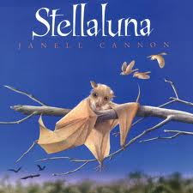

Speaking and Listening 2

Respond to and compose texts
- Discuss how writers and composers of texts engage the interest of the reader or viewer

Writing and representing 2
Develop and apply contextual knowledge
- Understand how characters, actions and events in imaginative texts can engage the reader or viewer

Reading and viewing 2
Develop and apply contextual knowledge
- Identify the audience and purpose of imaginative, informative and persuasive texts

Grammar, Punctuation and Vocabulary
Understand and apply knowledge of language forms and features
- Identify and use grammatical features, eg pronouns, conjunctions and connectives to accurately link ideas and information

Expressing themselves

Engage personally with text
- Recognise how aspects of personal perspective influence responses to texts

Understand and apply knowledge of language forms and features
- Make connections between students’ own experiences and those of characters and events represented in texts

Respond to and compose texts
- Identify the point of view in a text and suggest alternate points of view
- Justify personal opinions by citing evidence, negotiating with others and recognising opinions presented
- Recognise how aspects of personal perspective influence responses to texts

Understand and apply knowledge of language forms and features
- Make connections between students’ own experiences and those of characters and events represented in texts

Respond to and compose texts
- Identify the point of view in a text and suggest alternate points of view
- Justify personal opinions by citing evidence, negotiating with others and recognising opinions presented

Reflecting on learning

Understand and apply knowledge and language forms and features
- Appreciate how the reader or viewer can enjoy a range of literary experiences through texts

Respond to and compose texts
- Discuss the roles and responsibilities when working as a member of a group and understand the benefits of working collaboratively with peers to achieve a goal
- Reflect on own reading and identify the qualities of texts that have contributed to enjoyment of the text

Thinking imaginatively and creatively
Engage personally with text
- Respond to texts by identifying and discussing aspects of texts that relate to their own experience
Develop and apply contextual knowledge
- Discuss how authors and illustrators make stories exciting, moving and absorbing and hold readers’ interest by using various techniques, for example character development and plot tension
Respond to and compose texts
- Communicate the purposes of drawing and other visual media

 | Teaching/Learning Activities | Resources
Objective A  Communicate through speaking, listening, reading, writing, viewing and representing. | Brainstorm what students know about bats and birds. List similarities, differences.  Specific teaching about bats and birds – body coverings, characteristics, feeding, babies, etcn  Orientate to cover. Scan through first half of book, looking at illustrations. Predict story.  Read half the text and discuss. How did the author elaborate using words? Read the rest of the text, compare to own writing.  Look at quoted speech, use of italics, words that show emotion. | - Book “Stella Luna” by Janell Canon.  - Facts and information on bats and birds, utilising the internet
Objective B  Use language to shape and make meaning according to purpose, audience and context. | Assessment task: Write an information report on bats or birds. Publish using digital technology.  Write own ending to the story.  List words for feelings and emotions to display in the room. | - Large sheets of paper, textas  - Fact sheets or books on bats and birds for students to refer to
Objective C  Think in ways that are imaginative, creative, interpretive and critical. | Discuss character development – how was the baby bat feeling? How did the birds feel – babies, mother?  Roleplay story in groups, showing expressions depicting feelings. Use other scenarios to show emotions. | - Pictures of feelings and emotions  - Scenarios on cards for each group
Objective D  Express themselves and their relationships with others and their world. | What are the rules in the bird nest? What are the rules in society? At school? In different cultures? List laws and rules in school and in society.  Why do we need them? Discuss their own experiences of breaking rules. Consequences? Look at points of view of different people involved.  Discuss their own experiences of fitting in. Think of examples where it may be hard to fit in, eg starting at a new school, moving to a new house, living in a new country, bullying, being with people who are different from you.
Objective E  Learn and reflect on their learning through their study of English. | Discuss how we all have different skills and talents – bats, birds, people.  Discuss roles and responsibilities when working as part of a group, and the importance of working collaboratively.

Speaking and listening 1
Respond to and compose texts
- Use information to support and elaborate on a point of view

Writing and representing 1
Understand and apply knowledge of language forms and features
- Plan, draft and publish imaginative, informative and persuasive texts containing key information and supporting details for a widening range of audiences, demonstrationg increasing control over text structures and language features

H’Writing and using digital technologies
Respond to and compose texts
- Use a range of software, including word processing programs to construct, edit and publish written text, and select, edit and place visual, print and audio elements
Reading and viewing 1
Respond to, read and view texts
- Use comprehension strategies to build literal and inferred meaning to expand content knowledge, integrating and linking ideas and analysing and evaluating texts

Speaking and Listening 2

Respond to and compose texts
- Listen to and contribute to conversations and discussions to share information and ideas and negotiate in collaborative situations

Writing and representing 2
Understand and apply knowledge of language forms and features
- Use images in imaginative, informative and persuasive texts to enhance meaning

Reading and viewing 2
Develop and apply contextual knowledge
- Understand how texts vary in complexity and technicality depending on the approach to the topic, the purpose and the intended audience

Grammar, Punctuation and Vocabulary
Develop and apply contextual knowledge
- Understand that choice of vocabulary impacts on the effectiveness of texts

Content using Quality Text
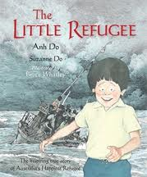

Expressing themselves
Engage personally with text
- Recognise how aspects of personal perspective influence responses to texts

Understand and apply knowledge of language forms and features
- Identify and compare the differences between texts from a range of cultures, languages and times

Respond to and compose texts
- Discuss aspects of literature from a range of cultures to explore common experiences and ideas aw well as recognising differences
- Respond to short films, documentaries and multimedia texts that express familiar and new aspects of the broader world

Reflecting on learning
Understand and apply knowledge and language forms and features
- Appreciate how the reader or viewer can enjoy a range of literary experiences through texts

Respond to and compose texts
- Reflect on own reading and identify the qualities of texts that have contributed to enjoyment of the text

Thinking imaginatively and creatively
Engage personally with text
- Share responses to a range of texts and identify features which increase reader enjoyment
Respond to and compose texts
- Justify interpretations of a text, including responses to characters, information and ideas

 | Teaching/Learning Activities | Resources
Objective A  Communicate through speaking, listening, reading, writing, viewing and representing. | Read text “The Little Refugee” by Anh Do. Discuss main ideas. Compare to Stellaluna text – similarities, differences, stereotypes, culture, points of view, characters.  Look at Harmony Day website www.harmony.gov.au and do some activities related to acceptance of others. Complete online activities.  View the Behind the News video clip ‘Refugee Kids’ which shows aspects of refugees’ positive experiences in Australia. Discuss how these refugee kids enjoy some of the ‘same’ activities as you might do. What different challenges might they face being a refugee kid?  Draw up a fact/opinion table and list:  List any facts about refugee kids presented in the video. What words, phrases or images are evidence for these facts?  List any opinions of the speakers. What words, phrases or images are evidence for these opinions?  Note some differences between the language of fact and that of opinion. Ask students to write a factual sentence about what they learned and an opinion sentence about what they now think about refugee kids. | “The Little Refugee” by Anh Do  websites, computer access for each student, interactive whiteboard for whole class lessons
Objective B  Use language to shape and make meaning according to purpose, audience and context. | How would Anh Do’s life as a child be different from theirs? How would he have felt going to school? When have students felt alone, different, left out?  Write a story about going to a new city or country, and how they would feel.
Objective C  Think in ways that are imaginative, creative, interpretive and critical. | Discuss the illustrations in the book “The Little Refugee”. Look at the use of colour. Why is this important? How do the images give us more information? Why are some images in sepia?  Students draw their own illustrations using colour and sepia, depicting scenes from their writing. | The Littlest Refugee
Objective D  Express themselves and their relationships with others and their world. | Discuss with students: what is a refugee? What is an asylum seeker? Which countries are they escaping from today? Use posters from Refugee Week to discuss images.  On the world map, locate Vietnam and plot Anh’s journey from Vietnam to Malaysia and then Australia. If available, use Google Earth to give a more dynamic view and tour of some of the places that are part of Anh’s journey.  As a class, list the situations that are encountered by Anh Do’s family on their journey by boat. Distribute a different situation to different groups and ask them to record answers to the following questions:  How might you feel in this situation?  Who or what might you be worried about?  Who could you help or who could help you in this situation?  Write down 10-15 things that you would take with you if you had to flee your home like Anh Do. They must be able to fit into a backpack and be carried by you. | World map  Posters of refugee week images  http://www.refugeecouncil.org.au./  Google earth
Objective E  Learn and reflect on their learning through their study of English. | Writing assessment task: Imagine a refugee student comes to our school. How would they feel? How would you respond to them? What might they have been through? How could you help?  Discuss what students have learnt from reading Stella Luna and The Littlest Refugee. Compare the similar messages in the texts, and how the authors portrayed these messages.

Speaking and Listening 2

Respond to and compose texts
- Listen to and contribute to conversations and discussions to share information and ideas and negotiate in collaborative situations

Writing and representing 2
Understand and apply knowledge of language forms and features
- Use images in imaginative, informative and persuasive texts to enhance meaning
- Respond to and compose texts

Reading and viewing 2
Develop and apply contextual knowledge
- Understand how texts vary in complexity and technicality depending on the approach to the topic, the purpose and the intended audience

Grammar, Punctuation and Vocabulary
Develop and apply contextual knowledge
- Understand that choice of vocabulary impacts on the effectiveness of texts

Content using Quality Text
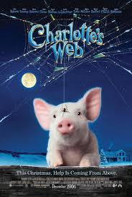

Reflecting on learning
Understand and apply knowledge and language forms and features
- Appreciate how the reader or viewer can enjoy a range of literary experiences through texts

Respond to and compose texts
- Reflect on own reading and identify the qualities of texts that have contributed to enjoyment of the text

Expressing themselves
Engage personally with text
- Recognise how aspects of personal perspective influence responses to texts

Respond to and compose texts
- Discuss aspects of literature from a range of cultures to explore common experiences and ideas aw well as recognising differences
- Respond to short films, documentaries and multimedia texts that express familiar and new aspects of the broader world

Thinking imaginatively and creatively
Engage personally with text
- Share responses to a range of texts and identify features which increase reader enjoyment
Respond to and compose texts
- Justify interpretations of a text, including responses to characters, information and ideas

Speaking and listening 1
Respond to and compose texts
- Use information to support and elaborate on a point of view

Reading and viewing 1
Respond to, read and view texts
- Develop & apply contextual knowledge
- Understand & apply knowledge of language forms and features

Reading and viewing 1
Respond to, read and view texts
- Use comprehension strategies to build literal and inferred meaning to expand content knowledge, integrating and linking ideas and analysing and evaluating texts

 | Teaching/Learning Activities | Resources
Objective A  Communicate through speaking, listening, reading, writing, viewing and representing. | Build background and set the stage by asking questions and discussing students’ responses, eg Who has visited a farm? What did you like most/least about farm life? What is a friend? What do you like about your friend? What do they like about you?  As you read the story, using the Hawker Brownlow Literature Unit, develop critical thinking with the Bloom’s Taxonomy story questions on pages 16, 17. | “Charlotte’s Web” by EB White  Charlotte’s Web Literature Unit (Hawker Brownlow)
Objective B  Use language to shape and make meaning according to purpose, audience and context. | Make several copies of the pig pattern on page 15 and write a story question on each pig.  Discuss the meaning of special words (listed on page 8) in context before reading each chapter. Make a pocket chart (see p 13) and create the Vocabulary Cards on blue ribbons (p. 15).  Have students conduct a “Pig Interview” (see p. 9).  Follow the directions in the recipes on p. 40 and 41 to create pancakes or play-dough.
Objective C  Think in ways that are imaginative, creative, interpretive and critical. | Create a spider web wall or bulletin board in the classroom (see directions on pages 27-19).  Have students create acrostic poems using the letters from one of the character’s names in Charlotte’s Web.  Use the play dough (recipe on p. 41) to recreate a farm scene.
Objective D  Express themselves and their relationships with others and their world. | Assessment task: After reading the book, have students reflect on the characters and events of the story, and about the meaning of friendship.  Use the Reader’s Theatre script on pages 44-47 to involve the students in drama. Use the follow-up questions on p.12 to discuss the qualities of a good friend.  Have students create contrast poems by introducing them to the poetic form of the diamante.
Objective E  Learn and reflect on their learning through their study of English. | After reading the book, watch the movie and discuss the differences and similarities between the book and the movie. Ask students which one they preferred and discuss why.  Use the Sentence strips to complete the activities on p.8, such as ordering and re-telling the story, and acting out parts of the story. | Charlotte’s Web DVD

Other resources: Charlotte’s Web DVD, Charlotte’s Web Literature Unit (Hawker Brownlow)
Assessment / Collecting Evidence : Assessment tasks are highlighted in red for each text
Observation
Anecdotal Records
Checklist / Matrix
Rubric (CTJ)
Self-Assessment
Peer Assessment
Student Teacher Conference
Journals
Assessment task

Possible Links to Other KLAs
Mathematics
Time lines
Venn diagrams, graphs
Measurement

Warragamba Public School Stage 2 2013
Science and Technology
- Use of IWB,
Digital technology for word processing

Life cycles
History
- Vietnam War
- Refugees and migrants

