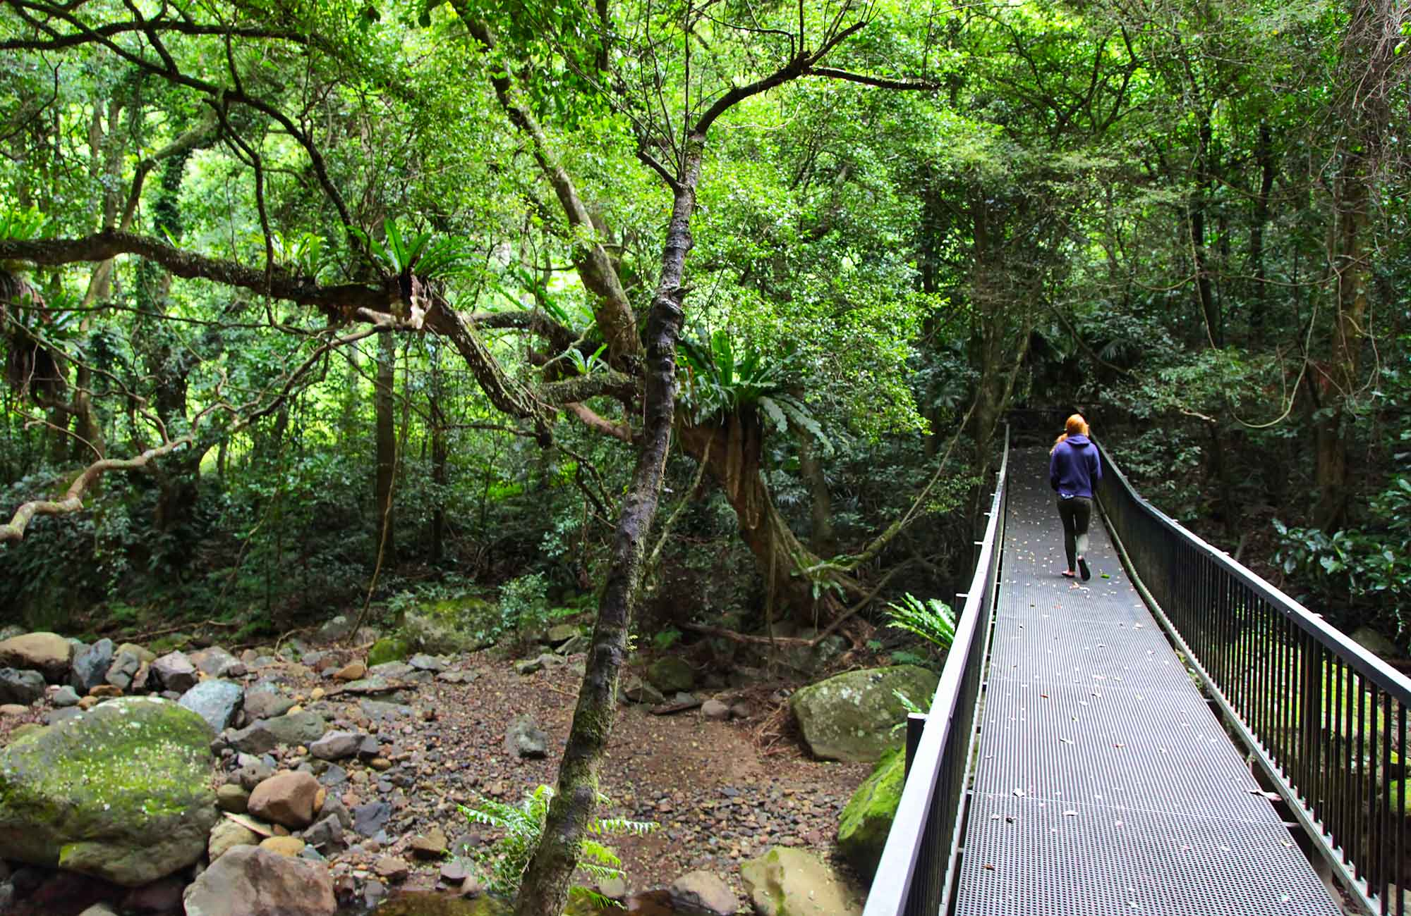
Stage 2

Time Frame - 10 weeks
Theme - The Environment

Key Concept - Visual Literacy, Making Connections

Focus for this unit - Learning Intention
Students will gain an understanding of environmental issues, conservation and the consequences of urban development. They will learn to interpret visual imagery in literacy texts.

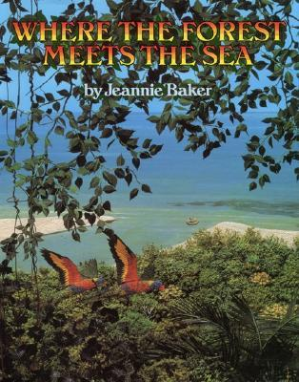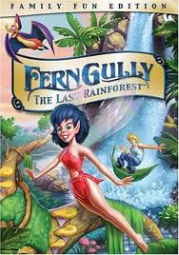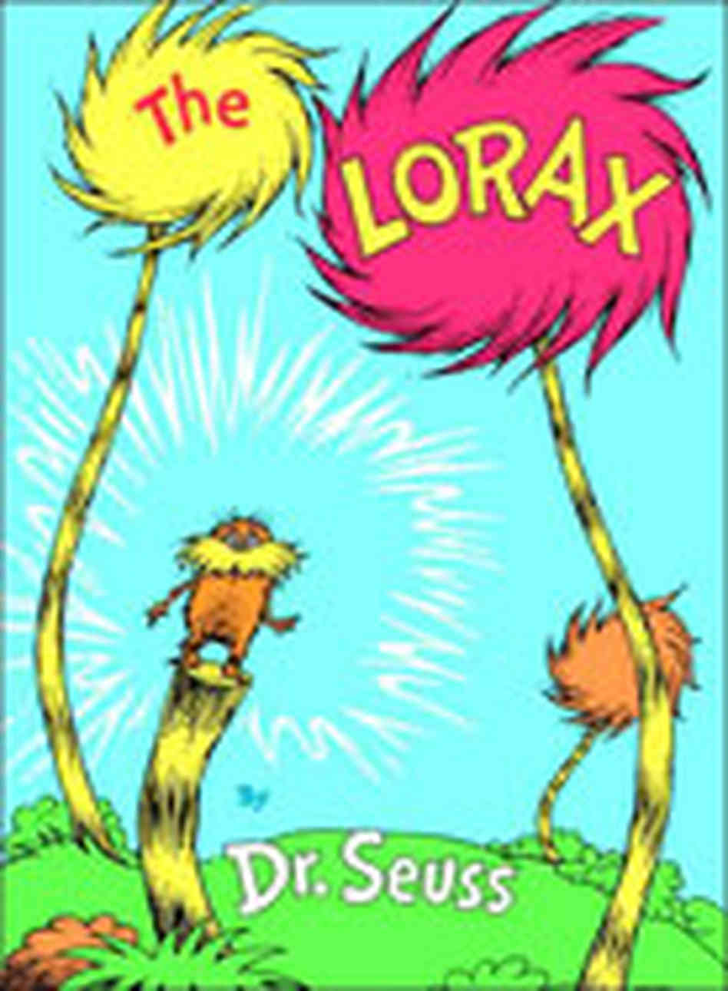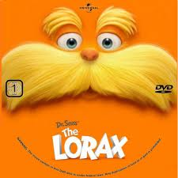

Objective A  Communicate through speaking, listening, reading, writing, viewing and representing. | Objective B  Use language to shape and make meaning according to purpose, audience and context. | Objective C  Think in ways that are imaginative, creative, interpretive and critical. | Objective D  Express themselves and their relationships with others and their world. | Objective E  Learn and reflect on their learning through their study of English.
Speaking and Listening 1  EN2-1A Communicates in a range of informal and formal contexts by adopting a range of roles in group, classroom, school and community contexts  - Develop & apply contextual knowledge  - Understand & apply knowledge of language forms and features.  - Respond to & compose texts  Writing & Representing 1  EN2-2A Plans, composes and reviews a range of texts that are more demanding in terms of topic, audience and language  - Develop & apply contextual knowledge  - Understand & apply knowledge of language forms and features  - Respond to & compose texts  H’writing & Digital Technologies  EN2-3A Uses effective handwriting and publishes texts using digital technologies  - Develop & apply contextual knowledge  - Understand & apply knowledge of language forms and features  - Respond to & compose texts  Reading & Viewing1  EN2-4A Uses an increasing range of skills, strategies and knowledge to fluently read, view and comprehend a range of texts on increasingly challenging topics in different media and technologies  - Develop & apply contextual knowledge  - Understand & apply knowledge of language forms and features  - Develop and apply graphological, phonological, syntactic & semantic knowledge.  - Respond to, read & view texts  Spelling  EN2-5A Uses a range of strategies, including knowledge of letter–sound correspondences and common letter patterns, to spell familiar and some unfamiliar words  - Develop & apply contextual knowledge  - Understand & apply knowledge of language forms and features  - Respond to & compose texts | Speaking and Listening 2  EN2-6B Identifies the effect of purpose and audience on spoken texts, distinguishes between different forms of English and identifies organisational patterns and features  - Develop & apply contextual knowledge  - Understand & apply knowledge of language forms and features  - Respond to & compose texts  Writing & Representing 2  EN2-7B Identifies and uses language forms and features in their own writing appropriate to a range of purposes, audiences and contexts  - Develop & apply contextual knowledge  - Understand & apply knowledge of language forms and features  - Respond to & compose texts  Reading & Viewing 2  EN2-8B Identifies and compares different kinds of texts when reading and viewing and shows an understanding of purpose, audience and subject matter  - Develop & apply contextual knowledge  - Understand & apply knowledge of language forms and features  - Respond to, read & view texts  Grammar, Punctuation & Vocab  EN2-9B Uses effective and accurate sentence structure, grammatical features, punctuation conventions and vocabulary relevant to the type of text when responding to and composing texts  - Develop & apply contextual knowledge  - Understand & apply knowledge of language forms and features  - Understanding & apply knowledge of vocabulary | Thinking Imaginatively & Creatively  EN2-10C Thinks imaginatively, creatively and interpretively about information, ideas and texts when responding to and composing texts  - Engage personally with texts  - Develop and apply contextual knowledge  - Understand and apply knowledge of language forms and features  - Respond to and compose texts | Expressing Themselves  EN2-11D Responds to and composes a range of texts that express viewpoints of the world similar to and different from their own  - Engage personally with texts  - Develop and apply contextual knowledge  - Understand and apply knowledge of language forms and features  - Respond to and compose texts | Reflecting on Learning  EN2-12E Recognises and uses an increasing range of strategies to reflect on their own and others’ learning  - Develop and apply contextual knowledge  - Understand and apply knowledge of language forms and features  - Respond to and compose texts

Reflecting on Learning
Understand and apply knowledge of language forms and features
• appreciate how the reader or viewer can enjoy a range of literary experiences through texts
Respond to and compose texts
• discuss the roles and responsibilities when working as a member of a group and understand the benefits of working collaboratively with peers to achieve a goal

Expressing Themselves
Respond to and compose texts
• make connections between students' own experiences and those of characters and events represented in texts

Thinking Imaginatively and Creatively
Engage personally with the text
• respond to texts by identifying and discussing aspects of texts that relate to their own experience
Respond to and compose texts
• create literary texts that explore students' own experiences and imagining

Speaking and Listening 2
Respond to and compose text
- discuss how writers and composers of texts engage the interest of the reader or viewer
- use persuasive language to compose simple persuasive texts appropriate to a range of contexts

Writing and Representing 2
Understand and apply knowledge of language forms and features
- use images in imaginative, informative and persuasive texts to enhance meaning
Reading and Viewing 2
Develop and apply contextual knowledge
- understand how texts vary in complexity and technicality depending on the approach to the topic, the purpose and the intended audience

Where The Forest Meets The Sea
By Jeannie Baker
Speaking and Listening 1
Develop and apply contextual knowledge
• interpret ideas and information in spoken texts and listen for key points in order to carry out tasks and use information to share and extend ideas and information
Reading and Viewing 1
Develop and apply contextual knowledge
•draw on experiences, knowledge of the topic or context to work out the meaning of unknown words.

 | Teaching/Learning Activities | Resources
Objective A  Communicate through speaking, listening, reading, writing, viewing and representing. | EN2-1A Speaking and Listening 1  - Rainforest bingo. Children write down a list of nine words that they can think of related to rainforests. Teacher has a list of rainforest words. Children mark off as teacher calls out rainforest words.  Orientate to cover.  - Discuss picture/cover relationship.  - Where do you think this is? Why?  - Why is there a lot of green?  - What about the birds?  - What is the person doing in the boat?  - What is happening in the picture?  - Discuss type of illustrations. Collage  EN2-4A Reading and Viewing 1  Scan through book (have words covered).  - Discuss illustrations. Teacher builds on children’s background knowledge of rainforests and threats to rainforests.  - Tell own story.  - Read book.  - Discuss as you go.  - Were your predictions correct? | - Paper  - Pencils  - Example list of words:  canopy debris decompose deforestation ecosystem emergent endangered fungi germinate greenhouse herbivore humus logging photosynthesis rainforest seedling shrub temperate tropical understorey  - ‘Where the Forest Meets the Sea’ by Jeannie Baker  - Post it notes to cover text
Objective B  Use language to shape and make meaning according to purpose, audience and context. | EN2-7B Writing and Representing 2  Writing own interpretations of illustration,  - With text covered, look at last page.  - Discuss as class.  - Write own text for the page. Remembering all text is 1 or 2 sentences per page.  - Read out/discuss.  - Look at issues of progress.  - What is deforestation?  - How do the illustrations get the message across?  EN2-6B Speaking and Listening 2  Responding to text.  - Discuss author’s purpose in using a small amount of text and large pictures.  - Non-emotive language-emphasis on images.  - Representing imagined images – visualisations.  EN2-8B Reading and Viewing 2  - Utilise books about rainforests (factual texts) to gain knowledge and understanding of rainforests and their importance to the environment.  - Make use of videos/IWB.  - View ‘Ferngully’ DVD.  - Discuss the effects of deforestation on animals and the environment. | - ‘Where the Forest Meets the Sea’ by Jeannie Baker  - Post it notes to cover text  - Paper  - Pencils  - http://www.rainforest-alliance.org/kids  - http://kids.mongabay.com/  - http://www.rainforestinfo.org.au/children/chlinks.htm  - Ferngully DVD
Objective C  Think in ways that are imaginative, creative, interpretive and critical. | EN2-10C Thinking Imaginatively and Creatively  - Discuss issues of progress and destruction of rainforests. (deforestation)  - Discuss local area issues.  - Develop mind map of local area issues.  - In groups, draft a letter to local council with concerns about a local environmental issue.  - Share with class.  - Exposition - Children given a possible scenario of a development in their local area, they are to write an exposition on what their views are towards this development. | - Paper  - Pencils
Objective D  Express themselves and their relationships with others and their world. | EN2-11D Expressing Themselves  - What is a rainforest?  - Have you been to a rainforest?  - Do you know where there is a rainforest?  - What animals would you find in a rainforest?  - Look at crocodile page and dinosaur page, why has the author used transparency in the images?  - Discuss past and future visualisations of rainforests.  - Engage personally with texts – own experiences – rainforests/beaches/ land clearing for development/resorts at beaches/holidays. | - ‘Where the Forest Meets the Sea’ by Jeannie Baker
Objective E  Learn and reflect on their learning through their study of English. | EN2-12E Reflecting on Learning  - Revise what is a Rainforest?  - Discuss thoughts on the book.  - Did you like it? Why/why not?  - Who do you think the books target audience is? Why?  - What did you learn from reading and discussing the book?  - Was it easier or more difficult to work in groups in some of the activities? Why?  - Pro’s and con’s of working together.  - Rainforest bingo-children write down a list of nine words that they can think of related to rainforests. Teacher has a list of rainforest words. Children mark off as teacher calls out rainforest words.  - Compare knowledge from beginning of unit.  - Quiz on rainforest. Include definitions of some bingo words. | - Paper  - Pencils

Writing and Representing 2
Understand and apply knowledge of language forms and features
• understand how audience and purpose influence the choice of vocabulary
Respond to and compose texts
• express a point of view for a particular purpose in writing, with supporting arguments

The Lorax
By Dr. Seuss

Reflecting on Learning
Develop and apply contextual knowledge
• recognise how own texts can be influenced by a rich text environment
Understand and apply knowledge of language forms and features
• appreciate how the reader or viewer can enjoy a range of literary experiences through texts

Expressing Themselves
Engage personally with texts
• recognise how aspects of personal perspective influence responses to texts
Respond to and compose texts
• justify personal opinions by citing evidence, negotiating with others and recognising opinions presented

Thinking Imaginatively and Creatively
Engage personally with the text
• share responses to a range of texts and identify features which increase reader enjoyment
Respond to and compose texts
• make connections between the ways different authors may represent similar storylines, ideas and relationships

Reading and Viewing 1
Develop and apply contextual knowledge
• identify and explain language features of texts from earlier times and compare with the vocabulary, images, layout and content of contemporary texts.

 | Teaching/Learning Activities | Resources
Objective A  Communicate through speaking, listening, reading, writing, viewing and representing. | EN2.4A – Reading and Viewing 1.  - View The Lorax.  - Use strategies to confirm predictions about author intent in imaginative, informative and persuasive texts.  - Use comprehension strategies to build literal and inferred meaning to expand content knowledge, integrating and linking ideas and analysing and evaluating texts.  - Identify syllables in multisyllabic words in order to support decoding of longer words in context to make meaning.  - Use text as an example from earlier times, to compare with the vocabulary, images, layout and context of contemporary times.  - Skim text for overall message and scan for particular information, including title, and key words. | http://www.youtube.com/watch?v=soRbNlPbHEo  - ‘The Lorax’ by Dr Seuss
Objective B  Use language to shape and make meaning according to purpose, audience and context. | EN2 – 7B Writing and Representing 2.  - Ask the class- How has the Lorax’s actions and the events in the story engaged them?  - Discuss how the author has used language to be more or less forceful. Discuss how the audience and purpose of the Lorax has influenced the use of vocabulary. For example, Dr Seuss uses made up words like, gruvvulous, rippulous, snargled, smogulous, and biggering.  - Write a persuasive letter from the point of view of the Lorax to ask the Once-ler to stop cutting down the trees. | - Paper  - Pencils  - ‘The Lorax’ by Dr Seuss  - List of made up words from The Lorax,
Objective C  Think in ways that are imaginative, creative, interpretive and critical. | EN2 – 10C Thinking Imaginatively and Creatively.  - Identify and discuss how the vocabulary in The Lorax has established setting, and atmosphere.  - The smogulous smoke being put in the air by the Thneed factory made the Lorax cough, whiff, sneeze, snuffle, snarggle, sniffle, and croak. The Swomee-Swans were no longer able to sing! The Lorax had to send the birds away to find some cleaner air to live in. Discuss air pollution with your student. Is it only dangerous for birds? No! It is dangerous for any creature that breathes.  - Responds to The Lorax by identifying and discussing aspects of their own experiences. Have they seen any rubbish in their school, on the side of the road, in the wider community, in their backyards. How clean is the air?  - One type of pollution we find evidence of is water pollution. "You're glumping the pond where the Humming-Fish hummed." All the Gluppity-Glupp and all the Schloppity-Schlopp made by the machinery chugging is being dumped right into the pond. What is the consequence of putting all this pollution into the water? (The fish can't live there anymore). Have your students think of any other problems this may cause? (the water wouldn't be fit to drink).  - Ask students to write an orientation for a narrative - establishing setting and atmosphere for a polluted environment. | - Paper  - Pencils  - ‘The Lorax’ by Dr Seuss  - Local knowledge of the school communities environment/ any polluted areas.
Objective D  Express themselves and their relationships with others and their world. | EN2-11D Expressing Themselves.  - Draw connections between personal experiences and the experiences of the Lorax.  - Discuss different ways to fight Pollution. You can help keep the air cleaner by riding a bike or walking instead of using a car where appropriate to do so. Recycle, Don't use spray products, plant a tree, and don't waste electricity.  - Have students share responses with their peers. "UNLESS someone like you...cares a whole awful lot...nothing is going to get better...It's not."  - Students design a plan to make the Truffula trees sustainable and economically viable. | - Paper  - Pencils  - ‘The Lorax’ by Dr Seuss  - Image of the Truffula Tree.
Objective E  Learn and reflect on their learning through their study of English. | EN2 – 12E Reflecting on Learning.  - Revise what is pollution.  - Discuss thoughts on ‘The Lorax’ by Dr Seuss.  - Did you like it? Why/why not?  - Who do you think the books target audience is? Why?  - What did you learn from reading and discussing the book? | - Paper  - Pencils  - ‘The Lorax’ by Dr Seuss

Assessment / Collecting Evidence
Observation  Anecdotal Records  Checklist / Matrix  Rubric (CTJ)  Self-Assessment  Peer Assessment  Student Teacher Conference  Journals  Assessment task | Ongoing throughout unit.  Ongoing throughout unit.  Exposition rubric  Assessment tasks occur throughout the units, these are highlighted.

Possible Links to Other KLA’s
Mathematics
Data- graphing
Timeline
Percentages

History
History of local area
History of a diminishing forest

Science & Technology
Life cycles – plant and animal
Computer graphics
Air pollution experiment

