Stage 2

Time Frame 2 weeks

Theme Fantasy

Key Concept Making Connections and Image

**Focus for this unit - learning intention**

*The following unit reflects ‘****Fantasy’*** *and its multiple perspectives. The unit aims to expose students to various realities and realms. Students will explore their own imagination and creativity through rich texts filled with diverse learning tools and techniques. The learning intentions surround ‘what is fantasy?’ and how does the composer use various strategies, forms and features to present the text to the responder. Students will examine different characters, settings and ideas that reflect fantasy and its elements. Different text comparisons are able to take place throughout the unit and each text will be discussed in depth. The students will achieve each learning objective and associate these objectives with key concepts. Students will engage and participate in a range of teaching and learning activities that foster the meaning and purpose of ‘****Fantasy****.’*

**Objective B**

**Speaking and Listening 2**

**EN2-6B** Identifies the effect of purpose and audience on spoken texts, distinguishes between different forms of English and identifies organisational patterns and features

* *plan, rehearse and deliver presentations incorporating learned content and taking into account the particular purposes and audiences*
* *discuss how writers and composers of texts engage the interest of the reader or viewer*
* *listen to and contribute to conversations and discussions to share information and ideas and negotiate in collaborative situations*
* *enhance presentations by using some basic oral presentation strategies, eg using notes as prompts, volume and change in emphasis*

**Objective A**

**Writing and Representing 1**

**EN2-2A** Plans, composes and reviews a range of texts that are more demanding in terms of topic, audience and language

* *plan, compose and review imaginative and persuasive texts*
* *plan and organise ideas using headings, graphic organisers, questions and mind maps*
* *identify elements of their writing that need improvement and review using feedback from teacher and peers*

**Reading and Viewing 1**

**EN2-4A** Uses an increasing range of skills, strategies and knowledge to fluently read, view and comprehend a range of texts on increasingly challenging topics in different media and technologies

* *draw on experiences, knowledge of the topic or context to work out the meaning of unknown words*
* *read texts using appropriate expression, eg pitch, pause, emphasis and attending to punctuation*
* *use comprehension strategies to build literal and inferred meaning to expand content knowledge, integrating and linking ideas and analysing and evaluating texts*
* *use strategies to confirm predictions about author intent in imaginative, informative and persuasive texts*
* *recognise how aspects of personal perspective influence responses to texts*
* *justify interpretations of a text, including responses to characters, information and ideas*

Theme:

Fantasy

Key Concept:

**Making Connections**

**Image**

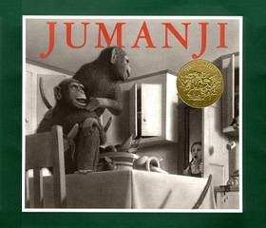

**Objective D**

**Expressing themselves**

**EN2-11D** Responds to and composes a range of texts that express viewpoints of the world similar to and different from their own

* *recognise how texts draw on a reader's or viewer's experience and knowledge to make meaning and enhance enjoyment*
* *recognise how aspects of personal perspective influence responses to texts*
* *draw connections between personal experiences and the worlds of texts, and share responses with others*
* *make connections between students' own experiences and those of characters and events represented in texts*
* *consider and discuss ideas drawn from their world and the worlds of their texts*
* *discuss literary experiences with others, sharing responses and expressing a point of view*
* *justify personal opinions by citing evidence, negotiating with others and recognising opinions presented*

**Objective C**

**Thinking imaginatively, creatively and interpretively**

**EN2-10C** Thinks imaginatively, creatively and interpretively about information, ideas and texts when responding to and composing texts

* *share responses to a range of texts and identify features which increase reader enjoyment*
* *respond to texts by identifying and discussing aspects of texts that relate to their own experience*
* *use visual representations, including those digitally produced, to represent ideas, experience and information for different purposes and audiences*
* *respond to a range of texts, eg through role-play or drama, for pleasure and enjoyment, and express thoughtful conclusions about those texts*
* *justify interpretations of a text, including responses to characters, information and ideas, eg 'The main character is selfish because …'*

**Objective E**

|  |  |  |
| --- | --- | --- |
|  | Teaching/Learning Activities | Resources |
| **Objective A**  **Communicate through speaking, listening, reading, writing, viewing and representing.** | * Preview the cover of the book, activating students’ prior knowledge and inviting predictions. Ask students to make predictions about what the book is about based on the cover. What do they think of the colour scheme? Etc. * Narrative Writing- Write about a similar situation where wild creatures and events enter into a person’s normal life, maybe at home, school or at the park. * Study the way Chris Van Allsburg wrote the instructions that are included with the Jumanji game. They follow a clear procedural manner. Students to write their own step by step instructions something they are confident at. | “Jumanji” Van Allsburg |
| **Objective B**  **Use language to shape and make meaning according to purpose, audience and context.** | * Dialogue is used extremely well throughout text. Study the punctuation of the dialogue and how it brings the text to life. Use this example of dialogue and encourage students to try and add it to their narratives. It can also be used to boost their reading fluency by reading out with expression. * Looking at the verbs Van Allsburg uses throughout the text, for example when Peter is chased by the lion. Ask the students to record the strong verbs they heard, such as dove, squeezed, scrambled, slammed and gasping. Explain why Van Allsburg used these verbs instead of boring and basic ones. Students could then write a boring verb against the strong one used in the text and compare. Encourage students to consider stronger verbs that describe the action in a more précised manner. * Look at the illustrations, what can you learn about the family from the home in Jumanji? In most homes, you can tell a good deal about the people who live there, just by looking at the objects with which they surround themselves. You could also examine the differences in the illustrations of the children throughout the book. | “Jumanji” Van Allsburg |
| **Objective C**  **Think in ways that are imaginative, creative, interpretive and critical.** | * What are the main messages/ lessons of the story “Jumanji”? Tell the students that writers usually include a lesson or a message in their stories that may not be actually written. As readers it is our job to determine what this message might be. After reading, allow students to share their thoughts with partners. Create a list of some of the big ideas your students uncover. They may   come up with ideas like “it is important to read the instructions thoroughly before starting something,” or “keep going even when  things get tough.” If students need more support you could ask these questions to stimulate their thinking.   * Have you ever played a game or put something together without reading the instructions? What happened? * What do you do when you are bored the way Peter and Judy were before they found the game? How do you ﬁnd imaginative ways to amuse yourself? * What might have happened to Peter and Judy if they had not read the instructions to Jumanji? What might happen to the Budwing boys? * How do Peter and Judy change as a result of their adventure with Jumanji? What have they learnt? * Discuss if there is any hint if it may have been all a dream? After all, the children are asleep when the adults arrive, and they don't believe the children's adventure, but what about the game that's being carried off by Daniel and Walter? You could have a mini class debate. * Design and create a board game which, if brought to life, would be very different for the players. Students will have to call it something different, of course. The magic word "Jumanji" will only work with that game. Students can design and name their own game in small groups. Make sure students think carefully about the rules of the game. Remind them to write the rules down! | “Jumanji” Van Allsburg |
| **Objective D**  **Express themselves and their relationships with others and their world.** | * Allow students to connect with other books or movies that are similar to Jumanji. This is a quest/ adventure story and the children must get to the end of the game. Can students find quests in other books, television shows and movies? * Brainstorm ways in which board games are better than, and not as good as, video games. Bring in your favourite board game and   have a session/ afternoon where all students can play. |  |
| **Objective E**  **Learn and reflect on their learning through their study of English.** |  |  |

|  |  |
| --- | --- |
| Assessment / Collecting Evidence | |
| Observation  Formal and Informal questions  Anecdotal Records  Oral Presentations  Assessment- Produce a Film | Student understanding may be assessed through the use of observational checklists, anecdotal records and analysis of contributions to class discussions.  Students engage in peer work and will be assessed based on completion of activity.  Students produce a variety of work samples, including producing a game board. These should be evaluated to determine students’ level of achievement and understanding. |

Possible Links to Other KLA’s

Science & Technology

History

* Personal History

Mathematics

* Position

**References:** Houghton Mifflin’s Teachers Guide for Jumanji By Chris Van Allsburg

Carol Hurst’s Children Literature Site, Jumanji, by Carol Otis Hurst and Rebecca Otis



|  |  |  |  |
| --- | --- | --- | --- |
| **Learning Unit Title** | [http://childhoodreading.com/wp-content/illustrations/Margaret_Tarrant/2081.JPEG](http://www.google.com.au/url?sa=i&rct=j&q=&esrc=s&frm=1&source=images&cd=&cad=rja&docid=PVLdQCNSdHa2NM&tbnid=jDHoC6AeVFGRdM:&ved=0CAUQjRw&url=http://childhoodreading.com/?p=30&ei=98BTUsK2J42glQWNuYDgDA&bvm=bv.53537100,d.dGI&psig=AFQjCNFrw4fLZsAauDaivSN9Nu4rvGpEFA&ust=1381306996430815) **My Shadow by Robert Louis Stevenson**  [http://upload.wikimedia.org/wikipedia/commons/thumb/1/1b/Robert_Louis_Stevenson_Knox_Series.jpg/300px-Robert_Louis_Stevenson_Knox_Series.jpg](http://www.google.com.au/url?sa=i&rct=j&q=&esrc=s&frm=1&source=images&cd=&cad=rja&docid=osEB6nz3hH5aoM&tbnid=nWDyhYzbe8CZ_M:&ved=0CAUQjRw&url=http://thebardonthehill.wordpress.com/2011/12/30/my-shadow-by-robert-louis-stevenson/&ei=IcFTUqzuIMLpkAWm5IBo&bvm=bv.53537100,d.dGI&psig=AFQjCNFrw4fLZsAauDaivSN9Nu4rvGpEFA&ust=1381306996430815) | | |
| **Literary device** | Words and images | | |
| **KLAs** | | **Stage** | **Duration** |
| English  CAPA  Science | | 2 | 2-3 weeks |

|  |  |
| --- | --- |
| **Learning Unit Outline** | |
| **Stage 2 Outcomes**  EN2-4A  EN2-6B  EN2-9B  EN2-10C | **Learning across the Curriculum**  Critical and Creative thinking  Literacy  ICT Information and Communication Technology  Personal and social capability |
| **Teaching and learning activities** | |
| 1. **Watch the youtube clip** : <http://www.youtube.com/watch?v=15NI3TKdoI0>   Discuss. Watch again with a copy of the poem. Discuss any unknown words or imagery. *Why did they use Peter Pan as the image for this poem?*  (Outcome Focus: EN2-10C)   1. **What does it mean? …** Discuss the overall meaning of the poem.   *Who is narrator?*  *What is the one thing about the shadow that is funny to the speaker?*  *In the 11th line of the poem it says “He’s a coward you can see”. What does this mean?*  *What are the three characteristics used to describe the shadow in the poem?*  *What does “notion” mean in line 9 of the poem?*  *What is a stanza? How many does this poem have?*  *How old do you think the narrator of the poem is? Use evidence from the poem to justify your answer.*  *Why does the shadow stay asleep in bed in the morning?*  (Outcome Focus: EN2-4A, EN2-6B, EN2-9B, EN2-10C)   1. **Rhyme**… Using a copy of the poem, highlight the last word in each line. Identify words that follow the same pattern. Identify the pattern in each stanza (AA BB)   (Outcome Focus: EN2-6B, EN2-9B)   1. **Similes…** What is a simile? Identify similes in the poem. Teacher to give examples of other sentences containing similes (eg: This afternoon mum was as busy as a bee). Find or create some other similes and illustrate them.   (Outcome Focus: EN2-6B, EN2-9B)   1. **Shades of meaning…** Working in small groups, develop a synonym set (eg: Little – tiny, microscopic, small, little, short, miniature). Groups will order these words by value or intensity. Encourage groups to think of other words they can add. How can these synonyms be used to improve your poem?   (Outcome Focus: EN2-4A, EN2-6B, EN2-9B)   1. **Research the author** – Robert Louis Stevenson. What was his inspiration for writing poetry with such vivid imagery?   <http://www.youtube.com/watch?v=zZKvW9u3Uxc>  (Outcome Focus: EN2-10C)   1. Investigate some other poems written by Robert Louis Stevenson   (Outcome Focus: EN2-10C) | |
| **Connections with other KLAs**  Science**:** Spinning in Space – Investigate shadows and how they change at different times of the day.  Art: Create a Silhouette image | |
| **Assessment** | |
| Observation during discussions. Reflecting on the text and the response of others. | |
| **Resources** | |
| Youtube links: <http://www.youtube.com/watch?v=15NI3TKdoI0> | <http://www.youtube.com/watch?v=zZKvW9u3Uxc> |

Time Frame 2 weeks

Theme Fantasy

Key Concepts Figurative language & Making connections

**Focus for this unit - learning intention**

*The following unit reflects* ***‘Fantasy’*** *and its multiple perspectives. The unit aims to expose students to various realities and realms. Students will explore their own imagination and creativity through rich texts filled with diverse learning tools and techniques. The learning intentions surround* ***‘what is fantasy?’*** *and how does the composer use various strategies, forms and features to present the text to the responder. Students will examine different characters, settings and ideas that reflect fantasy and its elements. Different text comparisons are able to take place throughout the unit and each text will be discussed in depth. The students will achieve each learning objective and associate these objectives with key concepts. Students will engage and participate in a range of teaching and learning activities that foster the meaning and purpose of* ***‘Fantasy.****’*

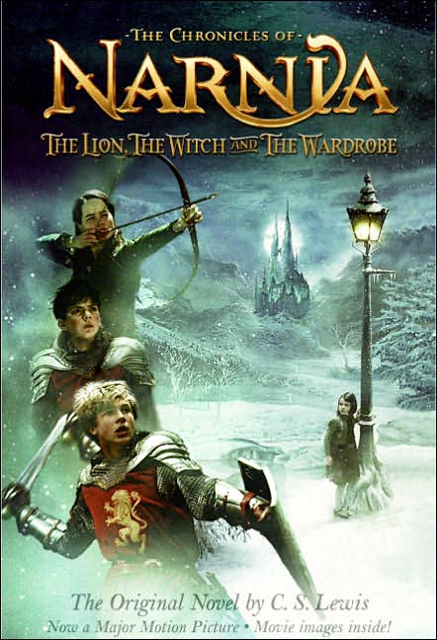

***Reading & Viewing 2***

**EN2-8B** Identifies and compares different kinds of texts when reading and viewing and shows an understanding of purpose, audience and subject matter

**Develop & apply contextual knowledge**

* Identify the audience and purpose of imaginative, informative and persuasive texts (ACELY 1678)
* Understands how texts vary in complexity and technicality depending on the approach to the topic, purpose and the intended audience (ACELA1490)

**Understand & apply knowledge of language forms and features**

* Understand how different types of texts vary in use of language choices, depending on their purpose and context (for example, tense and type of sentences) (ACELA1478)
* Recognise the use of figurative language in texts eg similes, metaphors, idioms and personification and discuss their effects

**Respond to, read & view texts**

* Respond to a wide range of literature and analyse purpose and audience.

**Movie trailer for Narnia**

http://www.youtube.com/watch?v=LshOd31d-yE



*Expressing Themselves*

EN2-11D Responds to and composes a range of texts that express viewpoints of the world similar to and different from their own

**Engage personally with texts**

* Recognise how texts draw on a reader’s or viewer’s experience and knowledge to make meaning and enhance enjoyment

**Develop and apply contextual knowledge**

* Draw connections between personal experiences and the worlds of texts, and share responses with others (ACELT1596)

**Understand and apply knowledge of language forms and features**

* Make connections between students’ own experiences and those of characters and events represented in texts

**Respond to and compose texts**

* Describe and discuss ethical issues encountered in texts
* Justify personal opinions by citing evidence, negotiating with others and recognising opinions presented.

|  |  |  |  |  |
| --- | --- | --- | --- | --- |
| **Objective A**  **Communicate through speaking, listening, reading, writing, viewing and representing.** | **Objective B**  **Use language to shape and make meaning according to purpose, audience and context.** | **Objective C**  **Think in ways that are imaginative, creative, interpretive and critical.** | **Objective D**  **Express themselves and their relationships with others and their world.** | **Objective E**  **Learn and reflect on their learning through their study of English.** |
| ***Speaking and Listening 1***  EN2-1A Communicates in a range of informal and formal contexts by adopting a range of roles in group, classroom, school and community contexts   * Develop & apply contextual knowledge * Understand & apply knowledge of language forms and features. * Respond to & compose texts   ***Writing & Representing 1***  EN2-2A Plans, composes and reviews a range of texts that are more demanding in terms of topic, audience and language   * Develop & apply contextual knowledge * Understand & apply knowledge of language forms and features * Respond to & compose texts   ***H’writing & Digital Technologies***  EN2-3A Uses effective handwriting and publishes texts using digital technologies   * Develop & apply contextual knowledge * Understand & apply knowledge of language forms and features * Respond to & compose texts   ***Reading & Viewing1***  EN2-4A Uses an increasing range of skills, strategies and knowledge to fluently read, view and comprehend a range of texts on increasingly challenging topics in different media and technologies   * Develop & apply contextual knowledge * Understand & apply knowledge of language forms and features * Develop and apply graphological, phonological, syntactic & semantic knowledge. * Respond to, read & view texts   ***Spelling***  EN2-5A Uses a range of strategies, including knowledge of letter–sound correspondences and common letter patterns, to spell familiar and some unfamiliar words   * Develop & apply contextual knowledge * Understand & apply knowledge of language forms and features * Respond to & compose texts | ***Speaking and Listening 2***  EN2-6B Identifies the effect of purpose and audience on spoken texts, distinguishes between different forms of English and identifies organisational patterns and features   * Develop & apply contextual knowledge * Understand & apply knowledge of language forms and features * Respond to & compose texts   ***Writing & Representing 2***  EN2-7B Identifies and uses language forms and features in their own writing appropriate to a range of purposes, audiences and contexts   * Develop & apply contextual knowledge * Understand & apply knowledge of language forms and features * Respond to & compose texts   ***Reading & Viewing 2***  EN2-8B Identifies and compares different kinds of texts when reading and viewing and shows an understanding of purpose, audience and subject matter   * Develop & apply contextual knowledge * Understand & apply knowledge of language forms and features * Respond to, read & view texts   ***Grammar, Punctuation & Vocab***  EN2-9B Uses effective and accurate sentence structure, grammatical features, punctuation conventions and vocabulary relevant to the type of text when responding to and composing texts   * Develop & apply contextual knowledge * Understand & apply knowledge of language forms and features * Understanding & apply knowledge of vocabulary | ***Thinking Imaginatively & Creatively***  EN2-10C Thinks imaginatively, creatively and interpretively about information, ideas and texts when responding to and composing texts   * Engage personally with texts * Develop and apply contextual knowledge * Understand and apply knowledge of language forms and features * Respond to and compose texts | ***Expressing Themselves***  EN2-11D Responds to and composes a range of texts that express viewpoints of the world similar to and different from their own   * Engage personally with texts * Develop and apply contextual knowledge * Understand and apply knowledge of language forms and features * Respond to and compose texts | ***Reflecting on Learning***  EN2-12E Recognises and uses an increasing range of strategies to reflect on their own and others’ learning   * Develop and apply contextual knowledge * Understand and apply knowledge of language forms and features * Respond to and compose texts |

|  |  |
| --- | --- |
|  | Teaching/Learning Activities |
| **Objective B**  **Use language to shape and make meaning according to purpose, audience and context.**  **Objective D**  **Think in ways that are imaginative, creative, interpretive and critical.** | The more you read the more you’ll begin to notice that many books begin with much background information on the main characters and/or setting of the novel. This often helps the reader figure out why the characters end up behaving the way they do.  **Read Chapter 1 of the text. (B)**  The Lion, the Witch and The Wardrobe begins during the onset of World War II in London, during which the German Nazis dropped bombs on the city. As a result, the Pevensie children are sent to live with the old professor in his countryside house. The series of events that lead up to the discovery of Narnia happen quickly and you may have many questions about the children and the professor that are left unanswered.  **How to set the scene (**B)  What would you like to know about the children, the professor, his house or the setting of the novel? Take 10 minutes to brainstorm with a member of your group and together write down a list of questions about the main characters or setting of the story (such as, Where are the children’s parents? Why is there a magical wardrobe in the professor’s house?).  Question: Where are the children’s parents?  Possible answer: The parents of Peter, Susan, Edmund and Lucy tearfully waved goodye at the train station as the children pulled away in a puff of steam from the engine. Just then, air raid sirens started roaring and their parents ran to seek cover.  **Question**: Why is there a magical wardrobe in the professor’s house?  **Possible answer:** For decades the professor worked on developing the perfect spell to enter other worlds. One day in his basement he used the wood from a special ellowberry tree, the only one in the world, to construct a fancy wardrobe. He poured the juice of ten hodgeberries, two frogs’ legs, mystical muir worms and tickle toad eyeballs onto the back of the wardrobe, hoping it would finally do the trick…   * Now it’s your turn to be imaginative and invent background information to complement the story. Piece together your crazy, creative answers to devise a beginning to the story. * Discuss **Figurative Language (B) -** Use the worksheet to model and teach about Simile, Metaphor, Personification, and Alliteration.          * Look at your background information piece. Modify and re-write it to include a simile, alliteration, metaphor or personification. * **(B)** Read the first part of the **Children’s picture book** of The Lion, The Witch and The Wardrobe. Has CS Lewis incorporated as much detail in his orientation? Why/ why not? What specific examples can you give of this? Who is the intended audience for each text? How did you come to that conclusion?   **Comparing the novel and the movie (B)**  The book and movie versions of *The Lion, The Witch and The Wardrobe* chronicle the same story, but in slightly different ways. Come up with a list of five differences you notice after reading the book and seeing the movie.  **Hint:** Examine the sequence of events and the passing of time in the professor’s house at the beginning.  1.  **Hint:** Take a look at the reasons behind why the children all run inside the wardrobe at once toward the beginning.  2.  **Hint:** Check out the battle scene between the good Narnians and the evil. How do the book and movie portray the fighting differently?  3.  **Hint:** Look at the very end of the book versus the movie, particularly the role of the professor when the children return from Narnia  4.  **Hint:** How are the girls regarded in the book versus the movie? In which form do they appear stronger and more courageous? Why do you think there is a difference in the portrayal?  5.  From your answers discuss how the book and movie differ in a variety of ways yet arrive at the same conclusion.  **Comparing the book and the movie discussion questions. (B)**  **1**. How did the beginning of the movie differ from the beginning of the book?  **2.** What was missing in the movie that was in the book?  **3.** Were there any characters or events that were present in the movie but not in the book?  **4**. Discuss the similarities and differences between how you imagined the creatures and characters from reading the book to seeing them on the screen.  **5**. Was the scenery the way you imagined it to be?  **6**. Does the movie end the same way the book does?   * **(B) Visualising scenes from the imagery that CS Lewis creates in his writing.**   Narnia is a world of imaginative scenery, creatures and magical happenings. C.S. Lewis does an excellent job of describing the characters, their emotions and the setting in exquisite detail.  Film adaptation is the process of transforming a written work like The Lion, The Witch and The Wardrobe into a feature film. Once the book becomes a movie script, all of the people working on the set of the movie can go about making decisions such as how the characters will look and how the scenery will appear, keeping in mind that they want to appeal to a commercial audience. Important jobs on a movie set include the costume designers, set designers and make-up artists who use information from the film adaptation to make the characters come to life. Try your hand at some design work by choosing from the detailed book excerpts below to create a drawing or collage that depicts the character or scene. Remember the importance of detail in making beloved literary characters and scenery come to life! Passage 1 – The White Witch The reindeer were about the size of Shetland ponies and their hair was so white that even the snow hardly looked white compared with them; their branching horns were gilded and shone like something on fire when the sunrise caught them. Their harness was of scarlet leather and covered with bells. On the sledge, driving the reindeer, sat a fat dwarf who would have been about three feet high if he had been standing. He was dressed in a polar bear’s fur and on his head he wore a red hood with a long gold tassel hanging from its point; his huge beard covered his knees and served him instead of a rug. But behind him, on a much higher seat in the middle of the sledge sat a very different person – a great lady, taller than any woman that Edmund had ever seen. She also was covered in white fur up to her throat and held a long straight golden wand in her right hand and wore a golden crown on her head. Her face was white – not merely pale, but white like snow or paper or icing sugar, except for her very red mouth. It was a beautiful face in other respects, but proud and cold and stern.  C.S. Lewis, *The Lion, The Witch and The Wardrobe,* p. 27 Passage 2 – The Beavers Meanwhile the girls were helping Mrs. Beaver to fill the kettle and lay the table and cut the bread and put the plates in the oven to heat and draw a huge jug of beer for Mr. Beaver from a barrel which stood in one corner of the house, and to put on the frying pan and get the dripping hot. Lucy thought the Beavers had a very snug home though it was not at all like Mr. Tumnus’s cave. There were no books or pictures and instead of beds there were bunks, like on board ship, built into the wall. And there were hams and strings of onions hanging from the roof and against the walls were gum boots and oilskins and hatchets and pairs of shears and spades and trowels and things for carrying mortar in and fishing rods and fishing nets and sacks. And the cloth on the table tho’ very clean was very rough.  C.S. Lewis, *The Lion, The Witch and The Wardrobe,* p. 69 Passage 3 – The Witch’s House But at last he came to a part where it was more level and the valley opened out. And there, on the other side of the river, quite close to him, in the middle of a little plain between two hills, saw what must be the White Witch’s house. And the moon was shining brighter than ever. The house was really a small castle. It seemed to be all towers; little towers with long pointed spires on them, sharp as needles. They looked like huge dunce’s caps or sorcerer’s caps. And they shone in the moonlight and their long shadows looked strange on the snow! Edmund began to be afraid of the house.  C.S. Lewis, *The Lion, The Witch and the Wardrobe,* p. 89 Passage 4 – Father Christmas It was a sledge, and it was a reindeer with bells on their harness. But they were far bigger than the Witch’s reindeer, and they were not white but brown. And on the sledge sat a person whom everyone knew the moment they set eyes on him. He was a huge man in bright red robe (bright as holly-berries) with a hood that had fur inside it and a great white beard that fell like a foamy waterfall over his chest. Everyone knew him because, though you see people of his sort only in Narnia, you see pictures of them and hear them talked about even in our world – the world on this side of the wardrobe door.  C.S. Lewis, *The Lion, The Witch and the Wardrobe,* p. 102  1 Passage 5 – Cair Paravel And Peter with his sword still drawn in his hand went with the Lion to the eastern edge of the hilltop. There a beautiful sight met their eyes. The sun was setting behind their backs. That meant that the whole country below them lay in the evening light – forest and hills and valleys and, winding away like a silver snake, the lower part of the great river. And beyond all this, miles away, was the sea, and beyond the sea the sky, full of clouds which were just turning roles colour with the reflection of the sunset. But just where the land of Narnia met the sea – in fact, at the mouth of the great river – there was something on a little hill, shining. It was shining because it was a castle and of course the sunlight was reflected from all the windows which looked towards Peter and the sunset; but to Peter it looked like a great star resting on the seashore.  C.S. Lewis, *The Lion, The Witch and the Wardrobe,* p. 125-126   * **Character Web** © - In *The Lion, The Witch and The Wardrobe,* the children begin the story as young kids, running around the old mansion in search of fun and adventure. The discovery of Narnia leads them on a difficult quest that tests their ability to become more courageous and make noble decisions in the face of the evil White Witch. The children are placed in a position of even greater responsibility with a prophecy stating that human children will come to the rescue of Narnia.   1. On the left-hand side write down a few characteristics of each sibling prior to the adventures in Narnia.  2. In the middle describe any turning events in the story that affect or change the character for the worse or better.  3. In the last column explain how this character ends up displaying the traits of his or her title as king or queen.    4. In the final row describe yourself prior to a changing point in your life so far. Describe this event or person who changed you. In the final column give yourself a title that reflects who you are now or who you wish to be in the future.  **Interacting with Strangers ©**  When Lucy first enters the wardrobe on her own she immediately befriends Mr. Tumnus, a faun who luckily ends up being a trustworthy companion. Conversely, when Edmund emerges from the wardrobe into Narnia, he runs into the White Witch, a stranger with bad intentions.  Read this except when the Queen is talking to Edmund:  My poor child,” she said in quite a different voice, “how cold you look! Come and sit with me here on the sledge and I will put my mantle around you and we will talk.”  Edmund did not like this arrangement at all but he dared not disobey; he stepped on to the sledge and sat at her feet, and she put a fold of her fur mantle around him and tucked it well in.  “Perhaps something hot to drink?” said the Queen. “Should you like that?”  “Yes please, your Majesty,” said Edmund, whose teeth were chattering.  C.S. Lewis, *The Lion, The Witch and The Wardrobe,* p. 30-31  **Discuss:**   * Did Lucy get lucky by running into a kind stranger? * Did Edmund make the wrong decision by talking with the White Witch and agreeing to eat the food she offered?   An important theme to be drawn from these interactions, despite coming from a fantasy tale, is how to react to situations with strangers. Parents often teach their young children the common saying, “Don’t talk to strangers.” Although it is infrequent, there have been incidents of strangers approaching children to cause harm. In Edmund’s case, the White Witch was pretending to be kind to use him as bait to capture the rest of his siblings.  **Step 1:** Split into four separate teams. Each group should take approximately 15 minutes to discuss the scenario and decide collectively how to respond to the situation. How do you interact or choose not to interact with the stranger? What is the end result?  **Step 2:** Write a brief skit to demonstrate your scenario to the group as a whole when you come together again. Make sure that roles are assigned and everyone feels included in the process (maybe a few people can write the scene and the others can act in it). Be sure to include your resolution in the skit, and be ready to explain to the group why you chose to end it that way. Film responses using an Ipad.    Read the following tips to learn about precautions you can take. Basic Tips for Dealing with Strangers  1. Stay away from a stranger who asks for help. Strangers should never ask children for directions or for help with something they can do themselves (or find another adult to help them), such as finding their keys or a lost pet. 2. Never accept items like candy or money from a stranger. 3. Never take a ride from a stranger, even if the stranger says your mother needs you or uses another excuse to get you. 4. Do not provide your name or address to a stranger. 5. Turn and run in the opposite direction if a stranger follows you in a car. If a stranger tries to follow you on foot or tries to grab you, run away, scream and tell your parents or a trusted adult friend. A dangerous stranger doesn’t want to be the center of attention. 6. Check with parents or a trusted adult before accepting a ride, even from someone you know. 7. Walk with other friends or with an adult because there is strength in numbers. |



|  |  |
| --- | --- |
| Assessment / Collecting Evidence | |
| Observation  Anecdotal Records  Checklist / Matrix  Rubric (CTJ)  Self-Assessment  Peer Assessment  Student Teacher Conference  Journals  Assessment task | * Modified version of the beginning of the story * Video of their skit * Detail within their visualisation from the imagery. |

Possible Links to Other KLA’s

History

Links to World War II

Time Frame: 2 weeks

Theme: Fantasy

Key Concept: Point of View, Visual representations

**Focus for this unit - learning intention**

*The following unit reflects* ***‘Fantasy’*** *and its multiple perspectives. The unit aims to expose students to various realities and realms. Students will explore their own imagination and creativity through rich texts filled with diverse learning tools and techniques. The learning intentions surround* ***‘what is fantasy?’*** *and how does the composer use various strategies, forms and features to present the text to the responder. Students will examine different characters, settings and ideas that reflect fantasy and its elements. Different text comparisons are able to take place throughout the unit and each text will be discussed in depth. The students will achieve each learning objective and associate these objectives with key concepts. Students will engage and participate in a range of teaching and learning activities that foster the meaning and purpose of* ***‘Fantasy.****’*

**Objective A:**

*Communicate through speaking, listening, reading, writing, viewing and representing*

Speaking and Listening 1: EN2-1A: communicates in a range of informal and formal contexts by adopting a range of roles in group, classroom, school and community contexts

[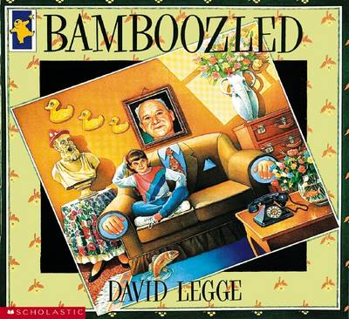](http://www.google.com.au/url?sa=i&rct=j&q=bamboozled-%20david%20legge&source=images&cd=&cad=rja&docid=eSAryYD3I3bwaM&tbnid=jVehQVz4KoZbaM:&ved=0CAUQjRw&url=http://www.boomerangbooks.com.au/Bamboozled/David-Legge/book_9781865045658.htm&ei=VH5TUprcEOnmiAf0moGoCQ&bvm=bv.53760139,d.cGE&psig=AFQjCNE59J8I0-XOh9qlgV6ydn-MFEDYyw&ust=13812899093540)

**Objective B**

*Use language to shape and make meaning according to purpose, audience and context*

Writing and Representing 2: EN2-7B: identifies and uses language forms and features in their own writing appropriate to a range of purposes, audiences and contexts



**Objective C**

*Think in ways that are imaginative, creative, interpretive and critical*

Thinking Imaginatively and Creatively: EN2-10C: Thinks imaginatively, creatively and interpretively about information, ideas and texts when responding to and composing texts.

**Objective D**

*Express themselves and their relationships with others and their world*

Expressing themselves: EN-11D: responds to and composes a range of texts that express viewpoints of the world similar to and different from their own.

|  |  |  |
| --- | --- | --- |
|  | Teaching/Learning Activities | Resources |
| **Objective A**  **Communicate through speaking, listening, reading, writing, viewing and representing.** | Develop and apply contextual knowledge: interpret ideas and information in spoken texts and listen for key points in order to carry out tasks and use information to share and extend ideas and information. **Focus on reading link: Making Connections**   1. Read the focus text to the students and give them time to **discuss** their thoughts with their peers. Read the book a second time and allow students again to discuss any changes or new findings after the second reading. Ask students to share their thoughts about what topics or themes might surface from this book eg: imagination, fantasy, illusion etc. Students find the definition of ‘**Bamboozled’ and ‘Fantasy’** *Concept- Visual representations* 2. Introduce the topic fantasy and ask students to make a **mini mind map** of words, other texts that relate to fantasy. *Concept- Visual representations* 3. Ask students to create **a point of view table.** Ask students to fill in what is happening in the text from the grandfather, the Childs and the reader’s point of view. Share. *Concept- Point of View*  |  |  |  | | --- | --- | --- | | **Grandad** | **Child** | **Reader** | |  |  |  | | Focus text: ‘Bamboozled’  English/ Writing Book |
| **Objective B**  **Use language to shape and make meaning according to purpose, audience and context.** | Develop and apply contextual knowledge: understand how characters, actions and events in imaginative texts can engage the reader or viewer. **Focus on reading link: visualising, predicting**   1. Students are shown a series of pictures and must decide if those pictures are real or fantasy. Together the class **will categorise** and discuss what makes these **images** real or fantasy and why. Students will them create the same categorising game but with images of the book. Students must decide what is real and what would be considered fantasy on each page. This can be done in small groups. This will require explanations as students may say that kangaroos are real but kangaroos cooking are not real. After categorising, students must create a series of fantasy images from the text to share on a display wall. *Concept- Visual representations* 2. Students will **answer the following questions**    * How does the composer engage in the reader?    * What are you thinking as you read the text?    * Explain the relationship between the written text and the images    * Why do you think the composer uses fantasy as a theme in this book?- *Concept-Point of View, Visual representations* | A range of images  Focus Text: ‘Bamboozled’  Display wall    English/Writing Books |
| **Objective C**  **Think in ways that are imaginative, creative, interpretive and critical.** | Engage personally with texts: respond to texts by identifying and discussing aspects of texts that relate to their own experience. **Focus on reading link: making connections**   1. Students read the text together as a class. Students **make a list of events** or images that relate to something that they are familiar with. Students will record how this connects to their own life. For example: a time when something strange has happened to them or another text that this reminds them of eg: Alice in Wonderland- *Concept- Visual representations* 2. In small groups students create a **role play** of an ordinary day or event eg: catching the school bus, making lunch in the kitchen. As a group insert 5 bamboozled/fantasy aspects and at the end of the performance the other students must guess the 5 bamboozles. *Concept- Visual representations* 3. Students create a **diary entry** pretending to be the child in the story. Students will write it from the characters point of view, drawing attention to key events and some odd things she may have noticed. *Concept- Point of View* 4. Students select a page form the text and create an **artistic representation**, changing the story slightly. They must change the setting of this page to a setting of their own choice and add in some odd/fantasy aspects. – *Concept- Visual representations* | Focus Text: ‘Bamboozled’  English/Writing Books |
| **Objective D**  **Express themselves and their relationships with others and their world.** | Develop and apply contextual knowledge: discuss how people from different times and cultures may respond differently to characters, actions and events in texts.  **Focus on reading link: making connections, predicting**   1. Students are to **re-write the ending of the text.**  Together in small groups, students will read the text and create a different ending.- *Concept- Point of View* 2. Students and teacher **discuss the differences between a child reading the text and an adult reading the text.** The teacher will draw attention to the different life experiences/ imaginations and fantasies that may change the reader’s perspective/ understanding of the text. Students select one aspect as an example of different points of view/ different responses to the text. *Concept- Point of View* 3. Students **answer the following questions** independently and share together with the class.  *Concept-Point of View, Visual representations*    * What would a person without a grandfather think when they were reading this book?    * What would somebody from a third-world country think when they read this book?    * How does his text link to fantasy?    * What do the words tell us in this book?    * What do the images tell us in this book? | Focus Text: ‘Bamboozled’  English/Writing Books |

|  |  |
| --- | --- |
| Assessment / Collecting Evidence | |
| Observation  Anecdotal Records  Checklist / Matrix  Rubric (CTJ)  Self-Assessment  Peer Assessment  Student Teacher Conference  Journals  Assessment task | Observation, self-assessment, assessment task (questions) |

Possible Links to Other KLA’s

Science & Technology

Nature, environment, animals

History

Early Settlement-“Th Good Old Days”

Mathematics

Positioning

`

Stage 2

Time Frame: 2 weeks

Theme: Fantasy

Key Concept: Visual representations, Making connections

**Focus for this unit - learning intention**

*The following unit reflects* ***‘Fantasy’*** *and its multiple perspectives. The unit aims to expose students to various realities and realms. Students will explore their own imagination and creativity through rich texts filled with diverse learning tools and techniques. The learning intentions surround* ***‘what is fantasy?’*** *and how does the composer use various strategies, forms and features to present the text to the responder. Students will examine different characters, settings and ideas that reflect fantasy and its elements. Different text comparisons are able to take place throughout the unit and each text will be discussed in depth. The students will achieve each learning objective and associate these objectives with key concepts. Students will engage and participate in a range of teaching and learning activities that foster the meaning and purpose of* ***‘Fantasy.****’*

**Objective B**

*Use language to shape and make meaning according to purpose, audience and context*

Writing and Representing 2: EN2-7B: identifies and uses language forms and features in their own writing appropriate to a range of purposes, audiences and contexts



**Objective C**

*Think in ways that are imaginative, creative, interpretive and critical*

Thinking Imaginatively and Creatively: EN2-10C: Thinks imaginatively, creatively and interpretively about information, ideas and texts when responding to and composing texts.

**Objective D**

*Express themselves and their relationships with others and their world*

Expressing themselves: EN-11D: responds to and composes a range of texts that express viewpoints of the world similar to and different from their own.

|  |  |  |
| --- | --- | --- |
|  | Teaching/Learning Activities | Resources |
| **Objective A**  **Communicate through speaking, listening, reading, writing, viewing and representing.** |  |  |
| **Objective B**  **Use language to shape and make meaning according to purpose, audience and context.** | * + Discuss the use of adjectives in the story. Re-write or print the text from pages 32 and 33 and ask the class to highlight/count the adjectives.   + Looking at the adjectives used, ask the class to determine how many of these are opposites of each other.   + Thinking about animals, cars, toys or a topic of the student’s choice, write as many adjectives that assist in describing their appearance or features.   + Create a word wall of adjectives that could be used to describe objects using the student’s answers. | A range of images  Text: ‘Ark in the Park’  Word wall    Writing Books  Pencils |
| **Objective C**  **Think in ways that are imaginative, creative, interpretive and critical.** | * Putting yourself in the shoes of a pet in The Noah’s Ark, the students are to imagine they are the pet. What is it that you do each day? Who do you spend time with and what do you look forward to? * Students are to create a journal/diary for a day in the life of the pet. They are to write about each of the activities of the animal and include all routines they may complete. They must also include the pet’s wish or a description of the pet’s ideal family or person they would like to adopt them in the pet store like what had happened with a number of pets when Sophie was working there. | Text: ‘Ark in the Park’  Writing Book  Pencils |
| **Objective D**  **Express themselves and their relationships with others and their world.** | * + Discuss how Sophie and the Noah’s made wishes for things that they wanted in their lives. Mention that sometimes some people might have wishes that they want different things in their lives, and that sometimes these things may be a fantasy.   + Discuss the term fantasy and its meaning, asking students to think about an example of a fantasy that they may encounter.   + Sophie and Mr and Mrs Noah in the book have wishes, some of them come true in some way. Ask the class to think about their wishes and what it is they really want. Students are to write a list of their own wishes they might have made, making lists showing those that might be realistic and those that are not realistic. Compare in groups and then with the class some of the wishes and how unrealistic wishes are fantasy. | Text: ‘Ark in the Park’  Writing Books  Pencils |

|  |  |
| --- | --- |
| Assessment / Collecting Evidence | |
| Observation  Anecdotal Records  Checklist / Matrix  Rubric (CTJ)  Self-Assessment  Peer Assessment  Student Teacher Conference  Journals  Assessment task | Observation, self-assessment, assessment task (questions) |

Possible Links to Other KLA’s

Science & Technology

History

Mathematics

Theme Fantasy

**Focus for this unit - learning intention**

*The following unit reflects ‘****Fantasy’*** *and its multiple perspectives. The unit aims to expose students to various realities and realms. Students will explore their own imagination and creativity through rich texts filled with diverse learning tools and techniques. The learning intentions surround ‘what is fantasy?’ and how does the composer use various strategies, forms and features to present the text to the responder. Students will examine different characters, settings and ideas that reflect fantasy and its elements. Different text comparisons are able to take place throughout the unit and each text will be discussed in depth. The students will achieve each learning objective and associate these objectives with key concepts. Students will engage and participate in a range of teaching and learning activities that foster the meaning and purpose of ‘****Fantasy****.*

Stage 2

Time Frame 2 weeks

Key Concept Visual Literacy & Voice

**OBJECTIVE B**

*Use language to shape and make meaning according to purpose, audience and context*

SPEAKING AND LISTENING 2

* plan, rehearse and deliver presentations incorporating learned content and taking into account the particular purposes and audiences (ACELY1689)q
* enhance presentations by using some basic oral presentation strategies, eg using notes as prompts, volume and change in emphasis

WRITING AND REPRESENTING 2

* understand how a range of language features can shape readers' and viewers' understanding of subject matter

GRAMMAR, PUNCTUATION AND VOCABULARY

* understand that choice of vocabulary impacts on the effectiveness of texts
* understand that the meaning of sentences can be enriched through the use of noun groups/phrases and verb groups/phrases and prepositional phrases
* experiment with vocabulary choices to engage the listener or reader

**OBJECTIVE A**

*Communicate through speaking, listening, reading, writing, viewing and representing*

SPEAKING AND LISTENING 1

* interact effectively in groups or pairs, adopting a range of roles
* demonstrate understanding of ideas and issues in texts through dramatic representation, role-play and simulations

WRITING AND REPRESENTING 1

* understand, interpret and experiment with a range of devices and deliberate word play in poetry and other literary texts, for example nonsense words, spoonerisms, neologisms and puns (ACELT1606)

HANDWRITING AND USING DIGITAL TECHNOLOGIES

* recognise that effective handwriting and presentation of work is required in order to communicate effectively for a range of audiences

READING AND VIEWING 1

* draw on experiences, knowledge of the topic or context to work out the meaning of unknown words
* read texts, including poems and scripted drama, using appropriate expression, eg pitch, pause, emphasis and attending to punctuation
* summarise a paragraph and indicate the main idea, key points or key arguments in imaginative, informative and persuasive texts

Text:

**JABBERWOCKY**

by Lewis Carroll

Theme:

Fantasy

Key Concept:

**Visual Literacy**

**Voice**

**OBJECTIVE D**

*Responds to and composes a range of texts that express viewpoints of the world similar to and different from their own*

EXPRESSING THEMSELVES

* recognise how texts draw on a reader's or viewer's experience and knowledge to make meaning and enhance enjoyment
* make connections between students' own experiences and those of characters and events represented in texts

**OBJECTIVE C**

*Think in ways that are imaginative, creative, interpretive and critical*

THINKING IMAGINATIVELY, CREATIVELY AND INTERPRETIVELY

* discuss how authors and illustrators make stories exciting, moving and absorbing and hold readers' interest by using various techniques, for example character development and plot tension (ACELT1605)
* identify and discuss how vocabulary establishes setting and atmosphere
* create literary texts that explore students' own experiences and imagining (ACELT1607)
* use visual representations, including those digitally produced, to represent ideas, experience and information for different purposes and audiences
* respond to a range of texts, eg through role-play or drama, for pleasure and enjoyment, and express thoughtful conclusions about those texts
* make connections between the ways different authors may represent similar storylines, ideas and relationships (ACELT1594, ACELT1602)

[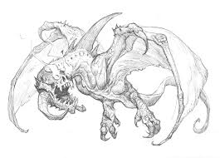](http://www.google.com.au/url?sa=i&rct=j&q=jabberwocky&source=images&cd=&cad=rja&docid=nzHCZftyRlvhfM&tbnid=lVLJVY4jWBaLMM:&ved=0CAUQjRw&url=http://prescottdrawblog.blogspot.com/2012/06/jabberwocky.html&ei=QICSUrncCYfKkgXw-4DQCQ&bvm=bv.56988011,d.dGI&psig=AFQjCNHx8owhL45koHNFEmG5pliJaFy98g&ust=1385419105631326)

**OBJECTIVE E**

*Learn and reflect on their learning through their study of English.*

REFLECTING ON LEARNING

* develop criteria for the successful completion of tasks
* jointly develop and use criteria for assessing their own and others' presentations

|  |  |  |
| --- | --- | --- |
|  | Teaching/Learning Activities | Resources |
| **Objective A**  **Communicate through speaking, listening, reading, writing, viewing and representing.** | * Revise narrative orientation purpose. Read only first stanza to students * Annotate the first verse marking grammatical purpose of nonsense words. * Replace nonsense words with known words without changing the gist of the story. Share. | *Jabberwocky* by Lewis Carroll  Power Point Presentation |
| **Objective B**  **Use language to shape and make meaning according to purpose, audience and context.** | * Read poem to class in a monotone voice. Ask students to verbally retell * Discuss how the use of expression can help make sense of the nonsense words. Perform the   whole poem for the class with expression. (Show Power Point at same time)   * Students retell story in their own words | *Jabberwocky* by Lewis Carroll  Power Point Presentation |
| **Objective B**  **Use language to shape and make meaning according to purpose, audience and context.** | * Discuss the nonsense words in the poem. What do they mean? What pictures do they   conjure up in the students’ minds?   * Discuss idea of nonsense poetry and how it’s used in “Jabberwocky” and other literary   works.   * Have the students find and highlight nonsense in the poem, and discuss the sound and spelling   of each word and list the words they may have been created from.   * Complete worksheet.   *Extension - Students could create their own nonsense words from words they know*. | *Jabberwocky* by Lewis Carroll  *Nonsense Words Worksheet* |
| **Objective E**  **Learn and reflect on their learning through their study of English.** | * Discuss how the expression in reading helps convey meaning. * As a class develop a checklist for marking a presentation of a reading. * Have small groups discuss the mood, feeling and expression of the poem and perform 1 stanza   of poem together.   * Have one member of each group assess each group’s presentation of their stanza | *Jabberwocky* by Lewis Carroll |
| **Objective C**  **Think in ways that are imaginative, creative, interpretive and critical.** | * Discuss what a Jabberwocky is. * View different artists’ illustration of the Jabberwocky * Draw their own Jabberwocky | *Jabberwocky* by Lewis Carroll  Jabberwockies Worksheet |
| **Objective D**  **Express themselves and their relationships with others and their world.** | * Create an information report on a Jabberwocky.   Include:  Different illustrations  Diet and habitat  Breeding and life cycle (what does a baby Jabberwocky look like)  *Extension – Discuss other myths and such as the Bunyip, Yeti, Loch Ness Monster.* | *Student’s own illustrations.*  *Other information texts as structure guides* |
| **Objective B**  **Use language to shape and make meaning according to purpose, audience and context.** | * Discuss how author may have chosen the nonsense words. * Complete Worksheet | *Jabberwocky* by Lewis Carroll  Word Choice Worksheet |

|  |  |
| --- | --- |
| Assessment / Collecting Evidence | |
| Observation  Formal and Informal questions  Anecdotal Records  Oral Presentations  Assessment- Produce an information text. | Student understanding may be assessed through the use of observational checklists, anecdotal records and analysis of contributions to class discussions.  Students efforts and presentation in public speaking activity.  Students produce a mini-book information text. |

Possible Links to Other KLA’s

Science & Technology

Classification of animals

History/HSIE

Cryptozoology

Myths and legends

Music

Rhythm and meter

Setting poem to music

The Jabberwocky

by Lewis Carrol

'Twas brillig, and the slithy toves

Did gyre and gimble in the wabe;

All mimsy were the borogoves,

And the mome raths outgrabe.

"Beware the Jabberwock, my son

The jaws that bite, the claws that catch!

Beware the Jubjub bird, and shun

The frumious Bandersnatch!"

He took his vorpal sword in hand;

Long time the manxome foe he sought—

So rested he by the Tumtum tree,

And stood awhile in thought.

And, as in uffish thought he stood,

The Jabberwock, with eyes of flame,

Came whiffling through the tulgey wood,

And burbled as it came!

One, two! One, two! And through and through

The vorpal blade went snicker-snack!

He left it dead, and with its head

He went galumphing back.

"And hast thou slain the Jabberwock?

Come to my arms, my beamish boy!

O frabjous day! Callooh! Callay!"

He chortled in his joy.

'Twas brillig, and the slithy toves

Did gyre and gimble in the wabe;

All mimsy were the borogoves,

And the mome raths outgrabe.

***The Jabberwocky***

***Word Choice***

What words that you know, or can find in the Dictionary and Thesaurus, do you think Lewis Carroll might have used to make up the words in his poem “Jabberwocky”

For example:

**“Toves”** could be made up of Doves, Elves and Turtle

**“Borogoves”** could be made up of Groves, Borders, & Burrows.

***[](http://www.google.com.au/url?sa=i&rct=j&q=jabberwocky&source=images&cd=&cad=rja&docid=nzHCZftyRlvhfM&tbnid=lVLJVY4jWBaLMM:&ved=0CAUQjRw&url=http://prescottdrawblog.blogspot.com/2012/06/jabberwocky.html&ei=QICSUrncCYfKkgXw-4DQCQ&bvm=bv.56988011,d.dGI&psig=AFQjCNHx8owhL45koHNFEmG5pliJaFy98g&ust=1385419105631326)***

|  |  |  |  |  |
| --- | --- | --- | --- | --- |
| Word | Word 1 | Word 2 | Word 3 | Word 4 |
| **brillig** |  |  |  |  |
| **slithy** |  |  |  |  |
| **gimble** |  |  |  |  |
| **frumious** |  |  |  |  |
| **uffish** |  |  |  |  |
| **whiffling** |  |  |  |  |
| **frabjous** |  |  |  |  |
| **outgrabe** |  |  |  |  |
| **vorpal** |  |  |  |  |
| **galumphing** |  |  |  |  |
| **maxome** |  |  |  |  |
| **burbled** |  |  |  |  |

|  |  |  |  |
| --- | --- | --- | --- |
| Jabberwocky - Nonsense Words  There are many words in The Jabberwocky that you have never head before.   1. List 12 of these words 2. See if you can find them in the dictionary (if you can, the word is not a nonsense word!) 3. Decide if the word is used as a noun, verb, adjective or adverb in Jabberwocky 4. Write some interesting known words that might replace this word. (A thesaurus might help you here) | | | |
| Word | Dictionary? | Noun/Verb/  Adjective/Adverb | Replacements |
|  |  |  |  |
|  |  |  |  |
|  |  |  |  |
|  |  |  |  |
|  |  |  |  |
|  |  |  |  |
|  |  |  |  |
|  |  |  |  |
|  |  |  |  |
|  |  |  |  |
|  |  |  |  |
|  |  |  |  |

[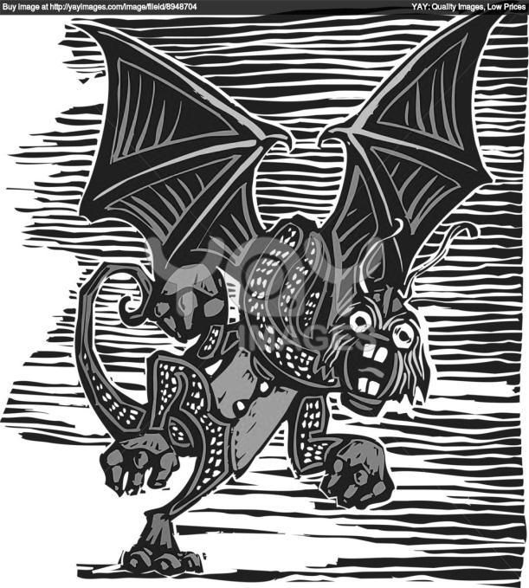](http://www.google.com.au/url?sa=i&rct=j&q=jabberwocky&source=images&cd=&cad=rja&docid=05BOyPGu7KuBXM&tbnid=FPSsWFhmMu3TJM:&ved=0CAUQjRw&url=http://yaymicro.com/vector/jabberwocky/4212690&ei=BlqVUqedHMjVkgWWwYDQAg&bvm=bv.57155469,d.dGI&psig=AFQjCNF4VVJVRTIrMzi2Nu1ZIEEuiO5tdQ&ust=1385605419233647)[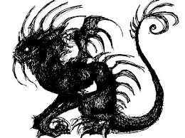](http://www.google.com.au/url?sa=i&rct=j&q=jabberwocky&source=images&cd=&cad=rja&docid=1Jj1uLResp4m4M&tbnid=ZWlqrkYxH9hXLM:&ved=0CAUQjRw&url=http://www.deviantart.com/morelikethis/artists/221457878?view_mode=2&ei=NVmVUuTKEciRkAX1_oHgDw&bvm=bv.57155469,d.dGI&psig=AFQjCNF4VVJVRTIrMzi2Nu1ZIEEuiO5tdQ&ust=1385605419233647)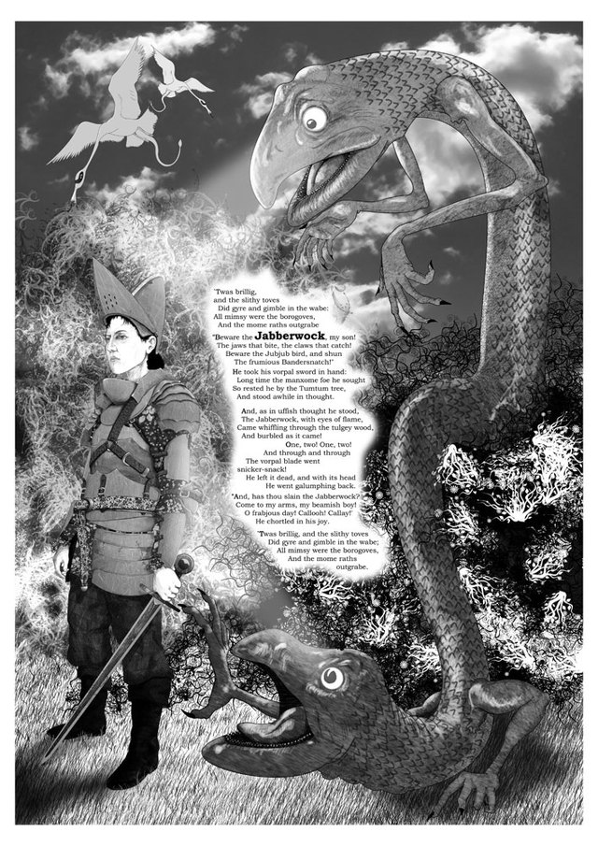JABBERWOCKIES

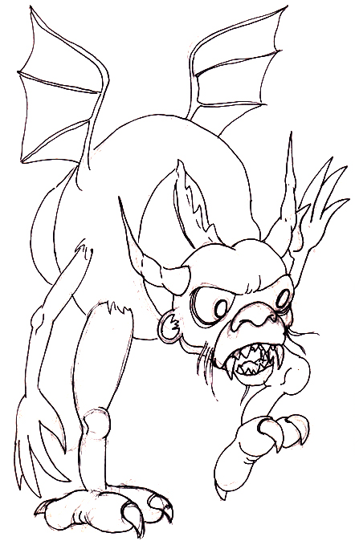[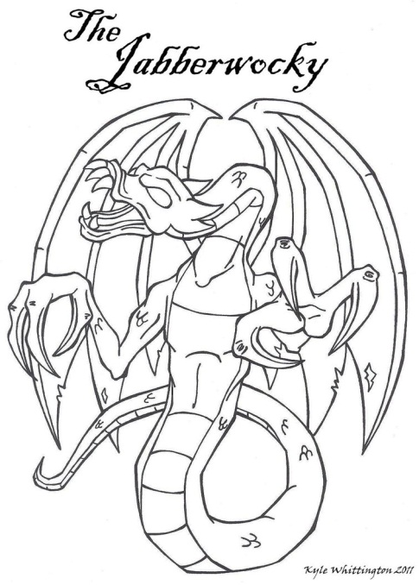](http://www.google.com.au/url?sa=i&rct=j&q=jabberwocky&source=images&cd=&docid=QjLAUU0p7rEg-M&tbnid=s-zvHLQhjYVkVM:&ved=0CAUQjRw&url=http://sketchmcdraw.deviantart.com/art/The-Jabberwocky-312630577&ei=ZH2VUs27KIWmlAXZlYHYCQ&bvm=bv.57155469,d.dGI&psig=AFQjCNExVhB3qzA-TJ7inJLBKABwT3iE7g&ust=1385614876216327)[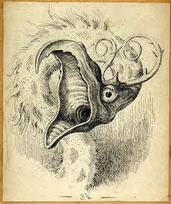](http://www.google.com.au/url?sa=i&rct=j&q=jabberwocky&source=images&cd=&cad=rja&docid=JgLNl1tUJrCXcM&tbnid=EWfCRDIwrOlM-M:&ved=0CAUQjRw&url=http://windfromnowhere.blogspot.com/2010_04_01_archive.html&ei=73-VUuHfA8yakgWPs4GwBQ&bvm=bv.57155469,d.dGI&psig=AFQjCNExVhB3qzA-TJ7inJLBKABwT3iE7g&ust=1385614876216327)[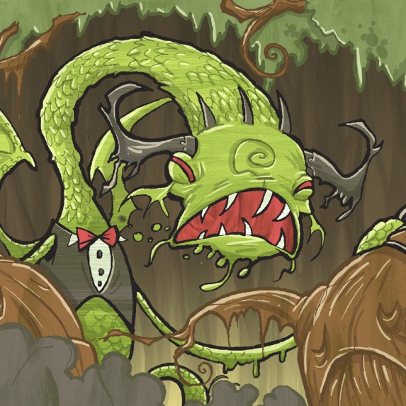](http://www.google.com.au/url?sa=i&rct=j&q=jabberwocky&source=images&cd=&cad=rja&docid=ky3Be49fH3nDcM&tbnid=i4vwhmeE4bD8OM:&ved=0CAUQjRw&url=http://www.impsandmonsters.com/shop/books/jabberwocky/&ei=ulmVUpPuAYKUkwXcy4GwDg&bvm=bv.57155469,d.dGI&psig=AFQjCNF4VVJVRTIrMzi2Nu1ZIEEuiO5tdQ&ust=1385605419233647)

**GLOSSARY – for teacher reference**

1. [gyre](https://www.vocabulary.com/dictionary/gyre)

a round shape formed by a series of concentric circles (as formed by leaves or flower petals)

NOTES:

The given definition is for "gyre" as a noun, but the example sentence is using it as a verb, which could connect to "gyrate" ("to wind or move in a spiral course"--often in a dance).

EXAMPLE SENTENCE:

*’Twas brillig, and the slithy toves   
Did* ***gyre*** *and gimble in the wabe;*

1. [beware](https://www.vocabulary.com/dictionary/beware)

be on one's guard; be cautious or wary about; be alert to

EXAMPLE SENTENCE:

*“****Beware*** *the Jabberwock, my son!*

1. https://d2oql1wfw8moob.cloudfront.net/images/icons/learn-q8bzb8.png[claw](https://www.vocabulary.com/dictionary/claw)

sharp curved horny process on the toe of a bird or some mammals or reptiles

EXAMPLE SENTENCE:

*The jaws that bite, the* ***claws*** *that catch!*

1. https://d2oql1wfw8moob.cloudfront.net/images/icons/learn-q8bzb8.png[shun](https://www.vocabulary.com/dictionary/shun)

avoid and stay away from deliberately; stay clear of

EXAMPLE SENTENCE:

*Beware the Jubjub bird, and* ***shun*** *The frumious Bandersnatch!*

1. https://d2oql1wfw8moob.cloudfront.net/images/icons/learn-q8bzb8.png[foe](https://www.vocabulary.com/dictionary/foe)

a personal enemy

EXAMPLE SENTENCE:

*Long time the manxome* ***foe*** *he sought—*

1. [sought](https://www.vocabulary.com/dictionary/sought)

that is looked for

NOTES:

The given definition is for "sought" as a noun, but it is being used as the past tense of the verb "seek"--the use of the word makes the father's words less like a warning to be afraid of and more like an announcement that a dream was soon to come true. Despite having sought the Jabberwock for so long, when his father told him to beware, he simply stood and waited for it to seek him out.

EXAMPLE SENTENCE:

*Long time the manxome foe he* ***sought****—*

1. https://d2oql1wfw8moob.cloudfront.net/images/icons/learn-q8bzb8.png[flame](https://www.vocabulary.com/dictionary/flame)

be in flames or aflame

EXAMPLE SENTENCE:

*The Jabberwock, with eyes of* ***flame****,   
Came whiffling through the tulgey wood,   
And burbled as it came!*

1. https://d2oql1wfw8moob.cloudfront.net/images/icons/learn-q8bzb8.png[through](https://www.vocabulary.com/dictionary/through)

over the whole distance

EXAMPLE SENTENCE:

*The Jabberwock, with eyes of flame,   
Came whiffling* ***through*** *the tulgey wood,   
And burbled as it came!*

1. [burble](https://www.vocabulary.com/dictionary/burble)

flow in an irregular current with a bubbling noise

NOTES:

"Burble" also means "babble" (which is possible because many of the animals that Alice encounters through the looking glass can talk) and "gurgle" (which is also possible because Alice found the poem in a book on the other side of the looking glass, where things often look or are backwards, so a scary monster that gurgles like a baby would not be out of place).

EXAMPLE SENTENCE:

*The Jabberwock, with eyes of flame,   
Came whiffling through the tulgey wood,   
And* ***burbled*** *as it came!*

1. https://d2oql1wfw8moob.cloudfront.net/images/icons/learn-q8bzb8.png[snicker](https://www.vocabulary.com/dictionary/snicker)

a disrespectful laugh

NOTES:

Although the phrase "snicker-snack" sounds more onomatopoeic than meaningful, it could suggest the image of the boy laughing disrespectfully while his blade made snicker-snacking sounds through the Jabberwock's body.

EXAMPLE SENTENCE:

*The vorpal blade went* ***snicker****-snack!*

1. [galumph](https://www.vocabulary.com/dictionary/galumph)

move around heavily and clumsily

EXAMPLE SENTENCE:

*He went* ***galumphing*** *back.*

1. https://d2oql1wfw8moob.cloudfront.net/images/icons/learn-q8bzb8.png[slay](https://www.vocabulary.com/dictionary/slay)

kill intentionally and with premeditation

EXAMPLE SENTENCE:

*“And hast thou slain the Jabberwock?*

1. [beamish](https://www.vocabulary.com/dictionary/beamish)

smiling with happiness or optimism

EXAMPLE SENTENCE:

*Come to my arms, my* ***beamish*** *boy!*

1. https://d2oql1wfw8moob.cloudfront.net/images/icons/learn-q8bzb8.png[chortle](https://www.vocabulary.com/dictionary/chortle)

laugh quietly or with restraint

EXAMPLE SENTENCE:

*He* ***chortled*** *in his joy.*

1. https://d2oql1wfw8moob.cloudfront.net/images/icons/learn-q8bzb8.png[gambol](https://www.vocabulary.com/dictionary/gambol)

play boisterously

NOTES:

The made-up word "gimble" sounds like the real word "gambol"--the definition fits the overall happy mood of this stanza that starts and ends a poem about the successful killing of a monster. But according to Carroll's Humpty Dumpty, "gimble" means "to make holes like a gimlet" (a gimlet is similar to a corkscrew, which the toves look like).

EXAMPLE SENTENCE:

*’Twas brillig, and the slithy toves   
Did gyre and gimble in the wabe;*