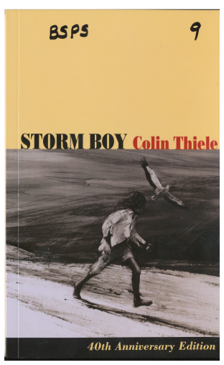

How do writers/authors convince/persuade others to agree with the point of view?
What strategies are emplyed to persuade?

Stage : S2 Term: Weeks:
Key Concept: |  | Bias - In argument or discussion, to favour one side or viewpoint by ignoring or excluding conflicting information; a prejudice against something.  Persuasion - The type of speaking or writing that is intended to make its audience adopt a certain opinion or pursue an action or do both.
Text set: |  | Storm Boy
Focus: |  | Integrating English Stage S2 outcomes for speaking and listening, reading and viewing, writing and representing, grammar and vocabulary (attached). Developing reading and composing skills using …………. vocabulary knowledge through persuasive texts. ??
Resources |  | Storm Boy, Way Home,  Cogs – Local Environment  You tube clip – Movie trailer, storm clip
Critical aspects: |  | Comprehension, Vocabulary, Reading texts, Writing
Learning across the curriculum: |  | Cogs Unit – Local Environment
Assessment: |  | Pre​ Assessment​  Do you prefer dogs or cats? Give your reasons with supporting evidence to justify your opinions.  Post Assessment  Compose a persuasive text (written, poster, role play, multi-modal, film, digital) that demonstrates an awareness of multiple perspectives or bias or point of view based on a particular issue. They can then persuade others to their point of view. (See attached Rubric A-E)
Term 2 | Teaching and Learning |  | R2L/ | Adjustments | Registration
Week
1  2  3  4  5  6  7  8 & 9 | Pre Assessment Task:  Do you prefer dogs or cats?  Give your reasons with supporting evidence to justify your opinions.  Introduce the text Storm Boy – Set the Scene, background information,  Show a youtube clip of a storm/creative art – discuss the different emotions taken from the storm, different points of views  Show youclip of storm boy trailer for the movie  Research the Coorong and present a detailed report or description  Follow spelling, grammar and punctuation scope and sequence.  Read pages 18-24  Students discuss characters, (role play of character traits and profiles) Character worksheet on justifying opinion on preferred character.  Comprehension tasks (here, hidden head)  Follow spelling, grammar and punctuation scope and sequence.  NAPLAN  Preparation and Participation  Pages 24-28 Storm Boy  Follow spelling, grammar and punctuation scope and sequence.  Watch make it possible video (selected parts of video)  - Discuss the issue, possible bias, one-sided  - Supporting evidence  - Persuassive devices eg (baby animals, visuals, giving the animals human like characteristics, music, lighting and emotion, feelings of animals  - Multiple responses/opinions  Select a response and discuss why you would have chosen that option. IS there another option. Children create a visual prop to use to help support an oral response to this issue.  Follow spelling, grammar and punctuation scope and sequence.  Watch a variety of youtube clips explain advertisements  Buy Me That: Helping Kids Understand Toy Ads  Food add tricks: Helping kids understand fast food ads on tv  Examples of persuasive adds – Spot Toyota Hilux Baby come up  Kelloggs LCMs 2010 Ad etc  Discuss the persuasive techniques used in advertising, audience, bias.Perspective  Students in pairs or group of 3 then create their own advertisement aimed at persuading their peers to purchase a fast food product of their choice.  Students then create an advertisement aimed at convincing consumers not to purchase fast food products.  Discuss the issue of animals living in zoos. List the reasons for and against. All perspectives need to be discussed and explored.  Explore the difference between a zoo and a sanctuary  Should sanctuaries or zoos be created for animals to live in?  Students research the benefits of sanctuaries/zoos and protecting animals.  Students then present a 3 page PowerPoint expressing the positives and benefits of each then finally making an informed decision and justifying with evidence their choice.  Continue reading Storm Boy  Complete a selection  Everyone should have their own vegetable garden  to be  self-sufficient!  Compose a persuasive text (written, poster, role play, multi-modal, film, digital) that demonstrates an awareness of multiple perspectives or bias or point of view based on a particular issue. They can then persuade others to their point of view.  Assessment Task |  | Begin reading the story up to page 17  Discuss and introduce new vocab  Introduce text Internet Ban for Australian Children.  Parents Should let children stay up late  Complete activity  Rewrite  Kangaroo Culling  Questions  Joint rewrite  Homework should be banned  Detailed reading pages 24-28  Comprehension questions  Joined rewrite of pelicans  Report of Pelicans  Detailed Reading pages 29-32  Comprehension questions  Joined Rewtite  Asking questions to ask Storm Boy  Text for and against zoos  R2L strategies | R2L adjustments  Reduced amount of work expected  Cut and paste activities  Reduced amount of work expected  High level of support given  R2L adjustments  Reduced amount of work expected  Cut and paste activities  R2L adjustments  Reduced amount of work expected  Cut and paste activities  R2L adjustments  Reduced amount of work expected  Cut and paste activities  R2L adjustments  Reduced amount of work expected  Cut and paste activities

