BATHURST SOUTH PS ENGLISH UNIT

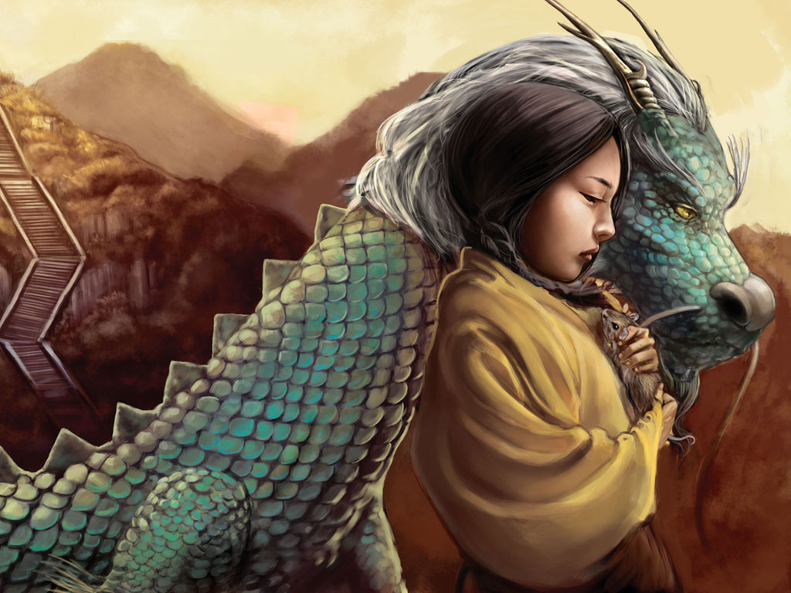
Stage 3
Characterisation

Stage : S3 Term:1 Weeks:1-10
Key Concept: |  | CHARACTERISATION  BIG QUESTION:WHAT MAKES A GOOD CHARACTER?
Text set: |  | DRAGON KEEPER by Carol Wilkinson
Focus: |  | Integrating English Stage S3 outcomes for speaking and listening, reading and viewing, writing and representing, grammar and vocabulary (attached). Developing reading and composing skills using …………. vocabulary knowledge through descriptive texts. ??
Critical aspects: |  | Comprehension, Vocabulary, Reading texts, Writing
Learning across the curriculum:
Assessment: |  | ​Pre-Assessment:​ ​  Students​ write​ a​ description​ of​ favourite​ character.  ​Post​-Assessment:​ ​​  1. From​ the​ studied​ text​ select​ a​ character​ and​ write​ description.​  2.Place​ this​ character​ in​ a​ scenario​ showing​ how​ the​ character​ would​ respond.  Mode​ of​ presentation​ of​ the​ character​ will​ be negotiated​ with​ students
Term 1 | Teaching and Learning |  | R2L | Adjustments | Registration
Week
1  2  3  4  5  6  7  8  9  10 | Introduction of text ‘Dragon Keeper’ by Carol Wilkinson  Pre-assessment: Students​ write​ a​ description​ of​ favourite​ character.  Engaging concept:  View Video”Shadow of Blue”  Talk about their impressions of the video  Introduce Reflection Journal  Grammar Link  \\Detnsw.win\3847\Faculty\Teacher\Public\1. KLAs\Australian Curriculum Implementation\Resources\English Programming Ideas\Bathurst South Scope & Sequences\Bathurst South grammar_punctuation_and_vocabulary_2014_draft.docx  Spelling Link  \\Detnsw.win\3847\Faculty\Teacher\Public\1. KLAs\Australian Curriculum Implementation\Resources\English Programming Ideas\Bathurst South Scope & Sequences\Bathurst South spelling_scope_and_sequence_2014_draft.docx  Continue to read Dragon Keeper  PowerPoint on ‘Characterisation –slides 1 to 13  \\Detnsw.win\3847\Faculty\Teacher\Public\1. KLAs\Australian Curriculum Implementation\Resources\English Programming Ideas\Stage 3\characterisation-dragon keeper\Characterisation.ppt  Reflection Journal-what are the 5 tips for characterization?  Introduce stencil with Character Traits for student to paste in their Literacy Books. \\Detnsw.win\3847\Faculty\Teacher\Public\1. KLAs\Australian Curriculum Implementation\Resources\English Programming Ideas\Stage 3\characterisation-dragon keeper\AListofCharacterTraits.pdf  Referring to Dragon Keeper character the Slave girl-highlight her characteristics in the early stages of the book. (reflection)  Grammar & Spelling (see link above)  Dragon Keeper Text-reading  \\Detnsw.win\3847\Faculty\Teacher\Public\1. KLAs\Australian Curriculum Implementation\Resources\English Programming Ideas\Stage 3\characterisation-dragon keeper\Dragon Keeper-detail reading1.docx  Identify Main Characters and discuss their traits.  Grammar & Spelling (see link above)  Dragon Keeper Text-reading  Read text on how Carol Wilkinson created her character.\\Detnsw.win\3847\Faculty\Teacher\Public\1. KLAs\Australian Curriculum Implementation\Resources\English Programming Ideas\Stage 3\characterisation-dragon keeper\developing the characters of Dragon Keeper.docx  List the initial character traits of Ping.  CHARACTER TRAITS  Characters-selection of pictures depicting different character traits. Groups discuss and categorise the pics according to traits.  (ref:Google images)  Partners select a pic and write about that character-giving them qualities, interests and background. (refer to their character traits lists)  Reflection Journal-have you described more than their physical appearance?  Continued reading of Dragon Keeper  Dragon Keeper Text-reading  Discuss how Ping’s character is changing-in what ways and what is happening to make her change?  Highlight further character traits she has developed from ‘Character Traits’ List (see link above)  Poem-‘Character V Personality  Watch the video and discuss the difference between ‘personality’ & ‘character’  Spelling & Grammar  Dragon Keeper Text-reading  Read Short story-refer to Characterisation PowerPoint- slides 18⁺  Complete activities within PowerPoint.  Spelling & Grammar  Dragon Keeper Text-reading  Detailed Reading  Finish reading Dragon Keeper  Make a book trailer on Dragon Keeper using moviemaker  On the completion of the book students could pair up and create their own Book Trailer.  Assessment tasks  1. From​ the​ studied​ text​ select​ a​ character​ and​ write​ a description.​  2.Place​ this​ character​ in​ a​ scenario​ showing​ how​ the​ character​ would​ respond. |  | Background Preparation  Notebook File  Words derived from text featuring spelling and grammar concept selected from Scope & Sequence  Detailed Reading  Pages 1&2  R2L Cycle  Detail Reading  Detailed Reading  Pages | R2L process  Directed questions for Reflection writing  R2L process  R2L process  Mode​ of​ presentation​ of​ the​ character​ will​ negotiated​ with​ students

