Wild, Wild World
A Stage 3 Literature Unit for the NSW K-10 English Syllabus
Key Concepts:
-Purpose
-Positioning
- Pathways/Navigation
- Figurative Language
Texts:
-Black Beauty
- National Geographic Kids website
- Poetry
- BBC Nature videos
Overview of Learning
Objective A | Objective B | Objective C | Objective D | Objective E
Speaking and Listening  EN3-1A Communicates effectively for a variety of audiences and purposes using increasingly challenging topics, ideas, issues and language forms and features  Understand and apply knowledge of language forms and features  *uses and describes language forms and features of spoken texts appropriate to a range of purposes, audiences and contexts  *develop criteria to evaluate the effectiveness of spoken texts  Respond to and compose texts  *participate in and contribute to discussions, clarifying and interrogating ideas, developing and supporting arguments, sharing and evaluating information, experiences and opinions (ACELY1709)  *plan, rehearse and deliver presentations, selecting and sequencing appropriate content and multimodal elements for defined audiences and purposes, making appropriate choices for modality and emphasis (ACEL1700, ACELT1795)  *discuss and experiment with ways to strengthen and refine spoken texts in order to entertain, to inform, persuade or inspire the audience  Writing and Representing  EN3-2A - Composes, edits and presents well-structured and coherent texts  Engages personally with the text  *Understand and appreciate the way texts are shaped through exploring a range of language forms and features and ideas  *experiment and use aspects of composing that enhance learning and enjoyment  Develop and apply contextual knowledge  *explore and analyse the effectiveness of informative and persuasive devices in texts  *understand and use the key elements of planning, composing, reviewing and publishing in order to meet the increasing demands of topic, audience and language  Understand and apply knowledge of language forms and features  *plan, draft and publish imaginative, informative and persuasive texts, choosing and experimenting with text structures, language features, images and digital resources appropriate to purpose and audience (ACELY1704, ACELY1714)  *understand, interpret and experiment with the use of imagery in imaginative texts, poetry and songs eg similes, metaphors, personification and sound devices such as alliteration (ACELT1611)  *compose increasingly complex print, visual, multimodal and visual texts, experimenting with language, design, layout and graphics  Reading and Viewing  EN3-3A - Uses an integrated range of skills, strategies and knowledge to read, view and comprehend a wide range of texts in different media and technologies  Respond to and compose texts  *use comprehension strategies to interpret and analyse information and ideas, comparing content from a variety of texutal sources including media and digital texts (ACELY1703, ACELY1713)  Understand and apply knowledge of language forms and features  *identify the impact of first-person and third-person narrative on the reader/viewer  * compare texts including media texts that represent ideas and events in different ways, explaining the effects of the different approaches (ACELY1708)  *explain sequences of images in print texts and compare thee to the ways hyperlinked digital texts are organised, explaining their effect on viewers’ interpretations (ACELA1511)  *understand, interpret and experiment with sound devices and imagery, including simile, metaphor and personification, in narratives, shape poetry, songs, anthems and odes  Respond to, read and view texts  *select, navigate and read texts for a range of purposes, applying appropriate text processing strategies and interpreting structural features | Responding and Composing  EN3-5B - Discuss how language is used to achieve a widening range of purposes for a widening range of audiences and contexts  Develop and apply contextual knowledge  *discuss how the intended audience, structure and context of an extended range of texts influence responses to texts  *identify and discuss how own texts have been structured to achieve their purpose and discuss ways of using conventions of language to shapes readers’ and viewers’ understanding of texts  Understand and apply knowledge of language forms and features  *identify and explain characteristic text structures and language features used in imaginative, informative and persuasive texts to meet the purpose of the text (ACELY1701)  *recognise the techniques used by writers to position a reader and influence their point of view  *investigate how the organisation of texts in chapters, headings, subheadings, home page and subpages for online texts and according to chronology or topic can be used to predict content and assist navigation (ACELA1797)  *identify the ways in which language in imaginative texts, including the use of figurative language, character development, events and setting, create interest for the reader or viewer  *discuss the conventions of a range of complex texts, eg act and stage directions in plays, literary devices in poems and stories, layout conventions in print and digital texts  Respond to and compose texts  *compose more complex texts using a variety of forms appropriate to purpose and audience  Grammar, Punctuation and Vocabulary  EN3-6B Use knowledge of sentence structure, grammar, punctuation and vocabulary to respond to and compose clear and cohesive texts in different media and technologies  Develop and apply contextual knowledge  *understand that choices in grammar, punctuation and vocabulary contribute to the effectiveness of texts  Understand and apply knowledge of vocabulary  *Understand the use of vocabulary to express greater precision of meaning, and know that words can have different meanings in different contexts (ACELA1512)  Respond to and compose texts  *select appropriate language for a purpose eg descriptive, persuasive, technical, evaluative, emotive and colloquial, when composing texts | Thinking imaginatively, creatively, interpretively and critically  EN3-7C - Thinks imaginatively, creatively, interpretively and critically about information and ideas and identifies connections between texts when responding to and composing texts  Engage personally with texts  *recognise and explain creative language features in imaginative, informative and persuasive texts that contribute to engagement and meaning  *interpret events, situations and characters in texts  *think critically about aspects of texts such as ideas and events  Develop and apply contextual knowledge  *explore and discuss simple appropriation of texts  Understand and apply knowledge of language forms and features  *understand how authors often innovate on text structures and play with language features to achieve particular aesthetic, humorous and persuasive purposes and effects (ACELA1518)  *identify the relationship between words, sounds, imagery and language patterns in narratives and poetry such as ballads, limericks and free verse  Respond to and compose texts  *Analyse and evaluate similarities and differences in texts on similar topics, themes or plots (ACELT1614) | Expressing themselves  EN3-8D - Identifies and considers how different viewpoints of their world, including aspects of culture, are represented in texts  Respond to and compose texts  *clarify understanding of content as it unfolds in formal and informal situations, connecting ideas to students’ own experiences and present and justify a point of view  *respond to short films, documentaries and texts that express familiar and new aspects of the broader world  *compose a variety of texts eg poetry, that reflect their understanding of the world around them  *discuss aspects of literature from a range of cultures to explore common experiences and ideas as well as recognising difference  Engages personally with the text  *recognise that ideas in literary texts can be conveyed from different viewpoints, which can lead to different kinds of interpretations and responses (ACELT1610)  *identify aspects of literary texts | Reflecting on Learning  EN3-9E - Recognises, reflects on an assess their strengths as a learner  Develop and apply contextual knowledge  *reflect on own learning achievements against specific criteria  Understand and apply knowledge of language forms and features  *discuss how the reader or viewer can enjoy and discover a wide range of literary experiences through texts  Respond to and compose texts  *formulate questions for specific purposes eg to clarify and reflect  *develop criteria for assessing their own and others’ presentations  *critically reflect on the effectiveness of their own and others’ writing, seeking and responding to feedback  *identify selections of own writing that they believe reflect their growth and competence as writers

Objective A
Speaking and Listening
EN3-1A
Respond to and compose texts
*participate in and contribute to discussions, clarifying and interrogating ideas, developing and supporting arguments, sharing and evaluating information, experiences and opinions (ACELY1709)
Reading and Viewing
EN3-3A - Uses an integrated range of skills, strategies and knowledge to read, view and comprehend a wide range of texts in different media and technologies
Understand and apply knowledge of language forms and features
*identify the impact of first-person and third-person narrative on the reader/viewer
Theme:
Wild, wild world
Key Concept:
Positioning

Objective C
Thinking imaginatively, creatively, interpretively and critically
EN3-7C - Thinks imaginatively, creatively, interpretively and critically about information and ideas and identifies connections between texts when responding to and composing texts
Engage personally with texts
*interpret events, situations and characters in texts
*think critically about aspects of texts such as ideas and events

Objective D
Expressing themselves
EN3-8D - Identifies and considers how different viewpoints of their world, including aspects of culture, are represented in texts
Engages personally with the text
*recognise that ideas in literary texts can be conveyed from different viewpoints, which can lead to different kinds of interpretations and responses (ACELT1610)
*identify aspects of literary texts

Text
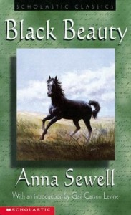

Objective B
Responding and Composing
EN3-5B - Discuss how language is used to achieve a widening range of purposes for a widening range of audiences and contexts
Develop and apply contextual knowledge
*discuss how the intended audience, structure and context of an extended range of texts influence responses to texts
Understand and apply knowledge of language forms and features
*recognise the techniques used by writers to position a reader and influence their point of view
Grammar, Punctuation and Vocabulary
EN3-6B Use knowledge of sentence structure, grammar, punctuation and vocabulary to respond to and compose cohesive texts in different media and technologies
Understand and apply knowledge of vocabulary
*investigate how vocabulary choice, including evaluative language, can express shades of meaning, feeling and opinion (ACELA1525)

Objective E
Reflecting on Learning
EN3-9E - Recognises, reflects on an assess their strengths as a learner
Understand and apply knowledge of language forms and features
*discuss how the reader or viewer can enjoy and discover a wide range of literary experiences through texts
Respond to and compose texts
*formulate questions for specific purposes eg to clarify and reflect

Text Overview
Black Beauty is written as an autobiography from the point of view of the horse of the same name. It provides a unique context for students to explore the impact of first-person narrative on a reader. While set in a historical context, it shows the cruelty faced by horses and other animals not only in the past but even today. Anna Sewell uses the first-person narrative to teach her readers about cruelty and respect for others, providing a way for students to develop their knowledge and understanding of this powerful writers’ tool.

 | Glossary
Positioning | The composing technique of causing the responder to adopt a particular point of view and interpret a text in a particular way.
Perspective | A way of regarding situations, facts and texts.

Cross-Curriculum Priorities | General Capabilities | BOS other learning areas | Grammar / Punctuation | Phonological / Graphological Processing
>Sustainability | >Ethical understanding  >Literacy  >Personal and social capability | >Civics and citizenship

Outcome | Resources | Teaching and Learning Activities (with adjustments) | Teachers Notes and Register
EN3-8D  EN3-5B, EN3-1A | Selection of familiar narratives eg Little Red Riding Hood, Cinderella, Peter Rabbit, Goldilocks etc  Access to You Tube  Rope, or similar to mark a circle for the students  Selection of texts with different narrative voices  Adjustments: Selection of texts for students to sort by narrative point of view | - Introduce the concept of talking about Positioning – the way that author’s write so the reader adopts a point of view about the text. Reflect on some familiar fairy tales, such as Little Red Riding Hood, Cinderella, Peter Rabbit etc. With which characters does the author want us to share a point of view? What parts of the text show this?  - Watch Narrative Point of View video from Mr Turner’s English (http://www.youtube.com/watch?v=sOVMM60Sm2c).  - Using a piece of rope, have groups of students demonstrate the four types of narration. Lay the rope out in a circle on the floor. Designate one student as the narrator and three others as characters so they can act out the type of narrative voice.  - Characters stand inside the circle  - If the narrator is inside the story, they should stand inside the circle with the characters  - If the narrator is outside of the story, the narrator should stand outside the circle  - If the narrator can read the character’s mind, the character should face the narrator  - If the narrator cannot read the character’s mind, the character should have his/her back to the narrator  Each group is given an example of a text to determine what type of narrative voice is being used. After examining their text, groups read aloud their text and position themselves around the rope to demonstrate and justify their answer.  - Brainstorm examples of texts that fit each of the narrative perspectives.  Adjustments: Teacher provide a selection of texts and ask students to sort them according to the narrative point of view. Discuss how the texts have been sorted. | Option – rewrite a familiar fairy tale from the point of view of another character  Option – read some of Roald Dahl’s Revolting Rhymes to see alternate perspectives of some fairy tales
EN3-3A, EN3-5B  EN3-1A | A copy for the teacher to read aloud  Copies of other narratives about animals eg. Charlotte’s Web, Peter Rabbit, White Fang | - Brainstorm a list of texts where animals are the central character. Present a few sections from some of these. Who is telling the story in each? In many stories, there is a third person narrator, usually a human, who is possibly unnamed.  - Read the first chapter (or part) of Black Beauty. From whose perspective is this written? (It is written as an autobiography of the horse, when he is older and looking back)Discuss the implication of this for a writer.  - Consider why Anna Sewell might choose this way to write her story. Record responses for reflection after reading the novel. | Texts chosen as samples for should reflect animal characters who display expected animal behaviours, apart from dialogue as much as possible  Responses could be shared and recorded as a class, or recorded independently in workbooks
EN3-7C, EN3-9E  EN3-3A, EN3-5B | Copies of the novel for all students  Adjustments: Junior novels or audio books for some readers | - Students independently read the novel.  Adjustments: Provide junior novelisation or an audio copy of the book for students unable to read the text independently. Teacher could read book aloud to students.  - What do you think the main message of the story was?  - Reflect on the question of why Anna Sewell wrote the story as the first person narrative. How do you think this influenced our point of view of the story and its message? Do you think she was effective in positioning the readers? Share examples that support your opinion. | Option…to pace the students in reading the text, feedback activities may be appropriate. This could include written responses to sections of the text or posts on a class blog.  Option…students could provide verbal response to this task, either informal through discussion, or more formal through a speech or oral presentation. A written response would also be suitable, in the form of a personal response or reflection  Option…students could provide verbal or written response to this question. Students could work in small groups or independently to present their perspective either formally or informally to the class

Theme:
Wild, wild world
Key Concept:
Purpose

Objective C
Thinking imaginatively, creatively, interpretively and critically
EN3-7C - Thinks imaginatively, creatively, interpretively and critically about information and ideas and identifies connections between texts when responding to and composing texts
Engage personally with texts
*recognise and explain creative language features in imaginative, informative and persuasive texts that contribute to engagement and meaning
Objective A
Speaking and Listening
EN3-1A Communicates effectively for a variety of audiences and purposes using increasingly challenging topics, ideas, issues and language forms and features
Understand and apply knowledge of language forms and features
*uses and describes language forms and features of spoken texts appropriate to a range of purposes, audiences and contexts
Writing and Representing
EN3-2A - Composes, edits and presents well-structured and coherent texts
Develop and apply contextual knowledge
*explore and analyse the effectiveness of informative and persuasive devices in texts
Reading and Viewing
EN3-3A - Uses an integrated range of skills, strategies and knowledge to read, view and comprehend a wide range of texts in different media and technologies
Respond to and compose texts
*use comprehension strategies to interpret and analyse information and ideas, comparing content from a variety of texutal sources including media and digital texts (ACELY1703, ACELY1713)

Objective D
Expressing themselves
EN3-8D - Identifies and considers how different viewpoints of their world, including aspects of culture, are represented in texts
Respond to and compose texts
*clarify understanding of content as it unfolds in formal and informal situations, connecting ideas to students’ own experiences and present and justify a point of view
*respond to short films, documentaries and texts that express familiar and new aspects of the broader world
Text
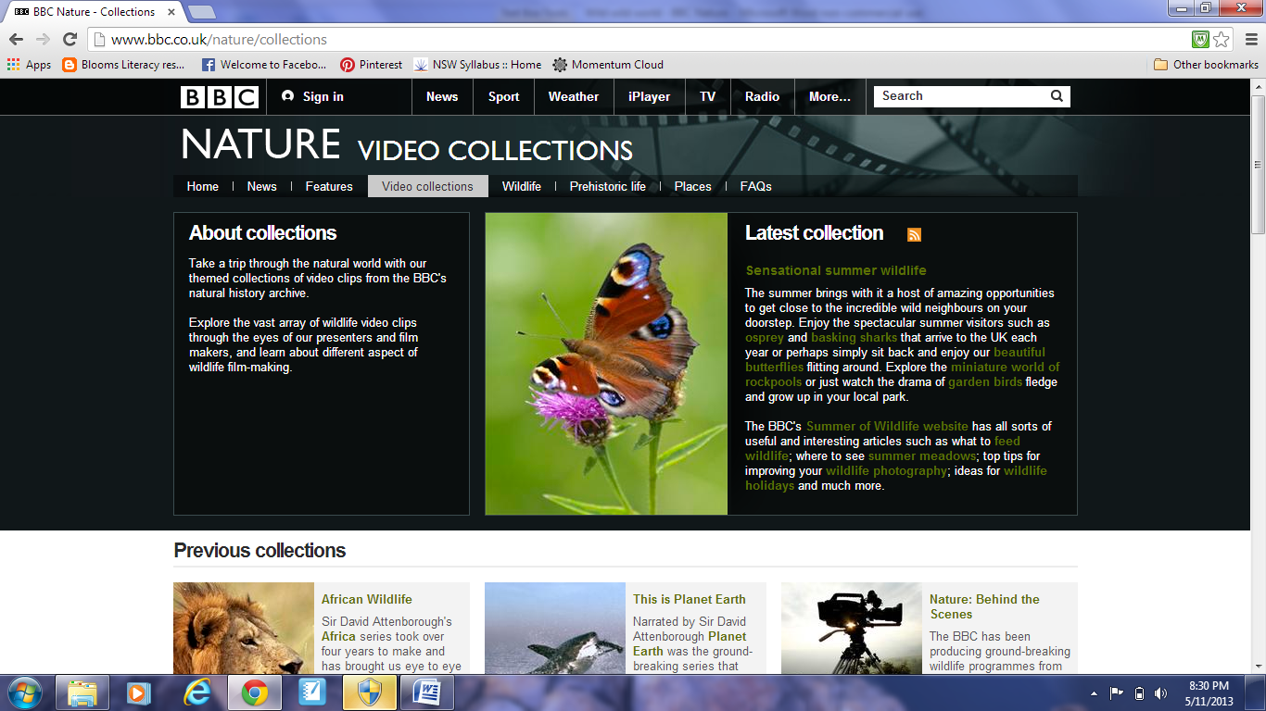
Bbc.co.uk/nature/collections (online version)

Objective B
Responding and Composing
EN3-5B - Discuss how language is used to achieve a widening range of purposes for a widening range of audiences and contexts
Develop and apply contextual knowledge
*discuss how the intended audience, structure and context of an extended range of texts influence responses to texts
Understand and apply knowledge of language forms and features
*identify and explain characteristic text structures and language features used in imaginative, informative and persuasive texts to meet the purpose of the text (ACELY1701)
Grammar, Punctuation and Vocabulary
EN3-6B Use knowledge of sentence structure, grammar, punctuation and vocabulary to respond to and compose clear and cohesive texts in different media and technologies
Develop and apply contextual knowledge
*understand that choices in grammar, punctuation and vocabulary contribute to the effectiveness of texts
Understand and apply knowledge of vocabulary
*Understand the use of vocabulary to express greater precision of meaning, and know that words can have different meanings in different contexts (ACELA1512)

Objective E
Reflecting on Learning
EN3-9E - Recognises, reflects on an assess their strengths as a learner
Understand and apply knowledge of language forms and features
*discuss how the reader or viewer can enjoy and discover a wide range of literary experiences through texts

Text Overview
BBC Nature has a broad library of documentaries available on its website. Many of these are available to view in individual segments, focussing on one main idea or detail. This makes them an ideal text for students as their size makes them readily accessible while still allowing students to be exposed to more complex texts and concepts on topics with which they are familiar. While the primary purpose of these texts is to inform, students will develop their understanding of the techniques used by writers and producers for the dual purpose of entertaining the audience.

 | Glossary
Purpose | The purpose of a text is to entertain, to inform or persuade different audiences in different contexts.
Audience | The intended group of readers, listeners or viewers that the writer, designer, film maker or speaker is addressing.
Context | The range of personal social, historical, cultural and workplace conditions in which a text is responded to and composed.

Cross-Curriculum Priorities | General Capabilities | BOS other learning areas | Grammar / Punctuation | Phonological / Graphological Processing
>Sustainability | >Critical and evaluative thinking  >Information and communication technology capability  >Literacy | >Difference and diversity

Outcome | Resources | Teaching and Learning Activities (with adjustments) | Teachers Notes and Register
EN3-3A, EN3-7C |  | - Review the 3 main purposes for authors choosing to compose texts. Working in small groups, students record on a mind map examples of texts for each purpose.  Adjustments: teacher may provide a variety of texts for students to sort by purpose.  Through discussion, justify the inclusion of texts by their features, language, structure etc  Adjustments: Teacher provide list of conventions of texts and ask students to match them to a purpose. | The acronym PIE may be useful for students to remember this.
EN3-3A,  EN3-6B | A range factual texts, both printed and digital, on animals | - Present a range of factual texts on animals to students working in small groups. Consider the texts and decide on their purpose. Groups provide feedback to the class, referring to the features of their text/s that justify their classification as an informative text. Use this feedback to create a list of features that are found in informative texts. These should include  - Written in the present tense  - Third person  - Information in clear sections, such as chapters, headings, paragraphs, subpages on a website  - Details, information and terms that might be needed to explain it better  Adjustments: Teacher may provide a list of text features and ask the students to choose which features are found in their texts and omit those that are not present.  - Once the list is complete, students can confirm if their text/s have all or some of these features.  Assessment: Provide students with a large copy of a page from a text and allow them to annotate the features of informative texts on the page. Display these around the class. | Option….annotate digital or online texts using iPad apps such as Explain Everything, Show Me or Educreations.
EN3-1A, EN3-5B, EN3-6B, EN3-8D, EN3-9E |  | - Introduce the BBC nature video to the students (either online or DVD). Ask the students to make prediction about the text, including its purpose, content, structure and other features.  - View the video from BBC Nature (If DVD, watch part of the video only).  Adjustments: Use subtitles to assist students with hearing impairment.  Predict what the purpose of this text is. What features did you notice in this text? What does it tell you about its purpose? Did it confirm or disprove your predictions? Could it have more than one purpose?  Adjustments: Teacher may like to provide students with a checklist of features which may or may not be in the video that they can check as they watch.  - Review the features of informative texts and confirm which were present in the video. Students watch either the same video again or another and record detailed examples of each of the features of informative texts. Students share their examples with a small group. | Option….a prompt or worksheet for students may assist with this.  Link….this learning experience links with those centred on the National Geographic Kids website. The knowledge and skills covered with this learning sequence can be applied by the students to the composition of their digital texts about animals.

Objective B
Responding and Composing
EN3-5B - Discuss how language is used to achieve a widening range of purposes for a widening range of audiences and contexts
Develop and apply contextual knowledge
*identify and discuss how own texts have been structured to achieve their purpose and discuss ways of using conventions of language to shapes readers’ and viewers’ understanding of texts
Understand and apply knowledge of language forms and features
*investigate how the organisation of texts in chapters, headings, subheadings, home page and subpages for online texts and according to chronology or topic can be used to predict content and assist navigation (ACELA1797)
*discuss the conventions of a range of complex texts, eg act and stage directions in plays, literary devices in poems and stories, layout conventions in print and digital texts
Respond to and compose texts
*compose more complex texts using a variety of forms appropriate to purpose and audience
ENS3-6B Use knowledge of sentence structure, grammar, punctuations and vocabulary
Respond to and compose texts
*select appropriate language for a purpose eg descriptive, persuasive, technical, evaluative, emotive and colloquial, when composing texts
Objective A
Speaking and Listening
EN3-1A Communicates effectively for a variety of audiences and purposes using increasingly challenging topics, ideas, issues and language forms and features
Understand and apply knowledge of language forms and features
*develop criteria to evaluate the effectiveness of spoken texts
Respond to and compose texts
*plan, rehearse and deliver presentations, selecting and sequencing appropriate content and multimodal elements for defined audiences and purposes, making appropriate choices for modality and emphasis (ACEL1700, ACELT1795)
*discuss and experiment with ways to strengthen and refine spoken texts in order to entertain, to inform, persuade or inspire the audience
Writing and Representing
EN3-2A - Composes, edits and presents well-structured and coherent texts
Develop and apply contextual knowledge
*understand and use the key elements of planning, composing, reviewing and publishing in order to meet the increasing demands of topic, audience and language
Understand and apply knowledge of language forms and features
*plan, draft and publish imaginative, informative and persuasive texts, choosing and experimenting with text structures, language features, images and digital resources appropriate to purpose and audience (ACELY1704, ACELY1714)
*compose increasingly complex print, visual, multimodal and visual texts, experimenting with language, design, layout and graphics
Reading and Viewing
EN3-3A - Uses an integrated range of skills, strategies and knowledge to read, view and comprehend a wide range of texts in different media and technologies
Understand and apply knowledge of language forms and features
* compare texts including media texts that represent ideas and events in different ways, explaining the effects of the different approaches (ACELY1708)
*explain sequences of images in print texts and compare thee to the ways hyperlinked digital texts are organised, explaining their effect on viewers’ interpretations (ACELA1511)
Respond to, read and view texts
*select, navigate and read texts for a range of purposes, applying appropriate text processing strategies and interpreting structural features
Theme:
Wild, wild world
Key Concept:
Pathways-Navigation/Reading

Text
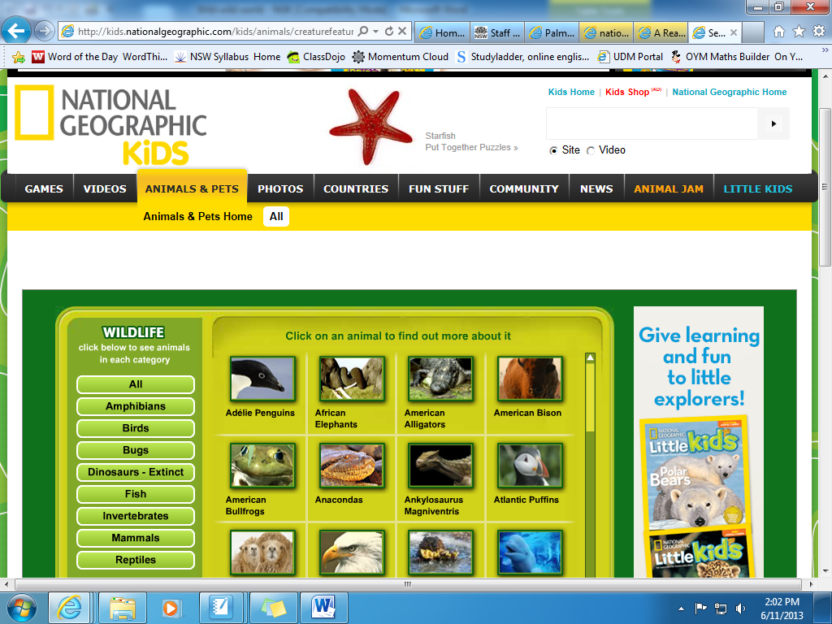
Kids.nationalgeographic.com/kids/ animals/creaturefeature/

Objective C
Thinking imaginatively, creatively, interpretively and critically
EN3-7C - Thinks imaginatively, creatively, interpretively and critically about information and ideas and identifies connections between texts when responding to and composing texts
Respond to and compose texts
*Analyse and evaluate similarities and differences in texts on similar topics, themes or plots (ACELT1614)

Objective E
Reflecting on Learning
EN3-9E - Recognises, reflects on an assess their strengths as a learner
Develop and apply contextual knowledge
*reflect on own learning achievements against specific criteria
Respond to and compose texts
*develop criteria for assessing their own and others’ presentations
Objective D
Expressing themselves
EN3-8D - Identifies and considers how different viewpoints of their world, including aspects of culture, are represented in texts
Respond to and compose texts
*compose a variety of texts eg poetry, that reflect their understanding of the world around them

Text Overview
Digital texts are an abundant and readily accessible source of information for students. The National Geographic Kids Animals website allows students to develop their skills and understanding of digital texts, and the complexities they present through the multiple navigation pathways available. It provides a rich and authentic text, composed at an appropriate level for students, so they can master the skills and strategies required to comprehend this form of text.

 | Glossary
Pathways/navigation
Multimodal | A multimodal text uses a combination of two or more communication modes, for example print, image and spoken text as in a film or computer presentation.

Cross-Curriculum Priorities | General Capabilities | BOS other learning areas | Grammar / Punctuation | Phonological / Graphological Processing
 | >Critical and evaluative thinking  >Information and communication technology capability  >Literacy  >Personal and Social Capability | >Work and enterprise

Outcome | Resources | Teaching and Learning Activities (with adjustments) | Teachers Notes and Register
EN3-3A, EN3-5B | Selection of factual printed texts on animals | - Introduce a selection of printed factual texts about animals to the students. Discuss the features of the text that assist us to locate information efficiently.  Adjustments: Ensure a wide range of texts are available to cater for all reading levels within the class.  - Students discuss the PMI (Plus, Minus, Interesting) of using printed texts to research information about animals. Record responses to future references, either as a class or individually. | Choice of texts can be influenced by the interests of the students, or other topics in HSIE or Science eg. rainforests, Antarctica  A PMI worksheet may be helpful for students if they are recording individual responses
EN3-3A, EN3-5B  EN3-7C | IWB with access to internet  Rubric or checklist for assessment task | - Access the National Geographic Kids – Animals website on the IWB (kids.nationalgeo-graphic.com/kids/animals/creaturefeature/)  - Discuss the features of the website that help us to navigate our reading pathway. Discuss problems or difficulties that this could cause.  - Create a PMI of using digital texts for researching information about animals. Compare this to the PMI of using printed texts.  Assessment: Students prepare a written or oral discussion about the advantages and disadvantages of using digital texts to locate information on a given topic. | Students may use same sheet to compare or a separate sheet.
EN3-1A, EN3-2A, EN3-6B, EN3-8D | Paper for students to record criteria  Copies of criterion for each student assessment | - Students will work in small groups to discuss what information should be included in an information report on animals. Groups will report back to the class and create a criterion for the task.  Assessment: Students will use the criteria developed by the class to prepare an information report on an animal, using digital media. Peer and self-assessment will occur in small groups before the students present their report to the class.
EN3-9E | English journal, blog or video, depending on mode of reflection | - After all students have presented their reports, each will complete a personal reflection on the task, including their ability to understand and complete the task and the validity of the feedback they received. This could be a journal entry, either written or video, or responses on a class blog.

Objective C
Thinking imaginatively, creatively, interpretively and critically
EN3-7C - Thinks imaginatively, creatively, interpretively and critically about information and ideas and identifies connections between texts when responding to and composing texts
Engage personally with texts
*recognise and explain creative language features in imaginative, informative and persuasive texts that contribute to engagement and meaning
Develop and apply contextual knowledge
*explore and discuss simple appropriation of texts
Understand and apply knowledge of language forms and features
*understand how authors often innovate on text structures and play with language features to achieve particular aesthetic, humorous and persuasive purposes and effects (ACELA1518)
*identify the relationship between words, sounds, imagery and language patterns in narratives and poetry such as ballads, limericks and free verse
Objective A
Writing and Representing
EN3-2A - Composes, edits and presents well-structured and coherent texts
Engages personally with the text
*Understand and appreciate the way texts are shaped through exploring a range of language forms and features and ideas
*experiment and use aspects of composing that enhance learning and enjoyment
Develop and apply contextual knowledge
*plan, draft and publish imaginative, informative and persuasive texts, choosing and experimenting with text structures, language features, images, digital resources appropriate to purpose and audience (ACELY1704, ACELY1714)
*understand, interpret and experiment with the use of imagery in imaginative texts, poetry and songs eg similes, metaphors, personification and sound devices such as alliteration (ACELT1611)
Reading and Viewing
EN3-3A - Uses an integrated range of skills, strategies and knowledge to read, view and comprehend a wide range of texts in different media and technologies
Understand and apply knowledge of language forms and features
*understand, interpret and experiment with sound devices and imagery, including simile, metaphor and personification, in narratives, shape poetry, songs, anthems and odes
Theme:
Wild, wild world
Key Concept:
Figurative Language

Text
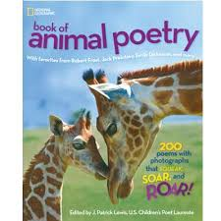

Objective D
Expressing themselves
EN3-8D - Identifies and considers how different viewpoints of their world, including aspects of culture, are represented in texts
Respond to and compose texts
*compose a variety of texts eg poetry, that reflect their understanding of the world around them
*discuss aspects of literature from a range of cultures to explore common experiences and ideas as well as recognising difference

Objective B
Responding and Composing
EN3-5B - Discuss how language is used to achieve a widening range of purposes for a widening range of audiences and contexts
Understand and apply knowledge of language forms and features
*identify the ways in which language in imaginative texts, including the use of figurative language, character development, events and setting, create interest for the reader or viewer
*discuss the conventions of a range of complex texts, eg act and stage directions in plays, literary devices in poems and stories, layout conventions in digital texts
Respond to and compose texts
*compose more complex texts using a variety of forms appropriate to purpose and audience

Objective E
Reflecting on Learning
EN3-9E - Recognises, reflects on an assess their strengths as a learner
Understand and apply knowledge of language forms and features
*discuss how the reader or viewer can enjoy and discover a wide range of literary experiences through texts
Respond to and compose texts
*critically reflect on the effectiveness of their own and others’ writing, seeking and responding to feedback
*identify selections of own writing that they believe reflect their growth and competence as writers

Text Overview
Poetry is a rich, varied and imaginative form that allows students to explore and experiment with the power of the English language. By experiencing poetry on the topic of animals, students can work with a familiar context and build an appreciation for poetry as a creative, powerful and valuable way to express themselves.

 | Glossary
Figurative language | Words or phrases used in a different way that differs from the expected or everyday use. Figurative language creates comparisons by linking the senses and the concrete to abstract ideas.
Appropriation | Taking an object or text from one context and using it in another context.

Cross-Curriculum Priorities | General Capabilities | BOS other learning areas | Grammar / Punctuation | Phonological / Graphological Processing
>Sustainability | >Critical and creative thinking  >Ethical understanding  >Intercultural understanding  >Literacy | >Civics and citizenship  >Difference and diversity

Outcome | Resources | Teaching and Learning Activities (with adjustments) | Teachers Notes and Register
EN3-5B | Mind map  Wall or other space to create a word bank | - Brainstorm with the students “What is poetry?” Record answers in a class mind map. Save this for future reference and reflection.  - Begin to build a class word bank of terminology used when reading and writing poetry, clarifying what these mean. Revisit any poetic devices the students may already know.  - Invite students to share any poems they know or enjoy. | This could be a whole class mind map or individual.
EN3-2A, EN3-3A, EN3-5B, EN3-7C | National Geographic Book of Children’s poetry  Selection of poems of various forms | For each poetic form, the same approach can be taken, thereby allowing students to build their knowledge and understanding of poetry and its forms.  - Read aloud the poem to the students as they follow along. Discuss what language features they identified during the reading.  - Identify the poetic form of the poem and highlight which features determine this. Consider a second example of the same form where appropriate.  - Jointly construct a poem on the subject of an animal. Reflect on the features of the poetic form being used and whether this poem has these.  - Students independently compose their own poem of this form. Editing, revising and rewriting should be completed independently, with peers and teacher assistance.  - Students share their completed poems within small, mixed ability groups in the class.  This can be repeated for several poetic forms. | It may be useful to create an anthology of the poems that will be used in the unit so the students have them readily accessible.
EN3-8D,  EN3-9E | Word processing software or other digital publishing tool | Assessment  - After composing many poems in a variety of forms, students will create an anthology of their own poems. By reflecting on their work, students select the pieces which they like best for publishing in their anthology.  - Students prepare a poetry recital, where all class members share poems they have written with a broader audience, such as teachers, parents, a peer group or wider invited audience.  Adjustments: Students unable to read their poem could provide a video recording of their reading, or arrange another student to read on their behalf.

Wild, Wild World Additional Resources and Activities

BLACK BEAUTY
- Comprehension activities – using each of the Super Six Strategies throughout the reading.
- Picture Summary for each (or few) chapters will provide a whole book summary.
- Writing – descriptive writing – choose an animal character from the books chosen and write a description of one. Use the description in a narrative.
- Teachers Pay Teachers Resource with lots of activities, including comprehension and writing - http://www.teacherspayteachers.com/Product/Black-Beauty-by-Anna-Sewell-Character-Plot-Setting-406582
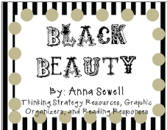
- Writing Unit – See below
POETRY
- A variety of science / animal related poem available at”
  - http://www.k12.hi.us/~shasincl/poems_arctic.html
  - http://www.canteach.ca/elementary/songspoems.html
- Poetry Dictionary for kids: http://www.poetry4kids.com/blog/lessons/poetry-dictionary-for-kids/
- Information on the range of poems and how to write them: http://www.kidzone.ws/poetry/index.htm

Writing – To Entertain Term 1, 2014

OUTCOME | A student: composes, edits and presents well-structured and coherent texts EN3-2A
MARKER 11 | • Writes coherent, structured texts for arange of purposes and contexts.  • Deliberately structures language in a way that creates more cohesive imaginative, informative and persuasive texts.  • Refines writing in response to feedback.  • Selects appropriate language for purpose, e.g. descriptive, persuasive, topic, technical, evaluative, emotive, and colloquial.  • Uses topic sentences and appropriately organises main and subordinate ideas.  • Experiments with using complex punctuation to engage the reader and achieve purpose.
CONTENT:
- Students:
- Engage personally with texts
- understand and appreciate the way texts are shaped through exploring a range of language forms and features and ideas
- experiment and use aspects of composing that enhance learning and enjoyment
- recognise and discuss issues related to the responsible use of digital communication
- Develop and apply contextual knowledge
- identify and explore underlying themes and central storylines in imaginative texts
- explore and analyse the effectiveness of informative and persuasive devices in texts
- understand and use the key elements of planning, composing, reviewing and publishing in order to meet the increasing demands of topic, audience and language
- Understand and apply knowledge of language forms and features
- plan, draft and publish imaginative, informative and persuasive texts, choosing and experimenting with text structures, language features, images and digital resources appropriate to purpose and audience (ACELY1704, ACELY1714)
- understand, interpret and experiment with the use of imagery in imaginative texts, poetry and songs, eg similes, metaphors, personification and sound devices such as alliteration
- understand that cohesive links can be made in texts by omitting or replacing words (ACELA1520)
- investigate how complex sentences can be used in a variety of ways to elaborate, extend and explain ideas (ACELA1522)
- Respond to and compose texts
- compose imaginative and informative texts that show evidence of developed ideas
- compose texts that include sustained and effective use of persuasive devices, eg texts dealing with environmental issues
- present a point of view about particular literary texts using appropriate metalanguage, and reflecting on the viewpoints of others (ACELT1609)
- create literary texts that experiment with structures, ideas and stylistic features of selected authors (ACELT1798)
- experiment with text structures and language features and their effects in creating literary texts, for example, using imagery, sentence variation, metaphor and word choice (ACELT1800)
- compose increasingly complex print, visual, multimodal and digital texts, experimenting with language, design, layout and graphics
- use increasingly complex research data from print and digital sources to compose short and sustained texts
- assess the reliability of resources, including digital resources, when researching topics
- reread and edit students' own and others' work using agreed criteria and explaining editing choices (ACELY1705, ACELY1715)
- develop a handwriting style that is legible, fluent and automatic and varies according to audience and purpose (ACELY1706, ACELY1716)
- use a range of software, including word processing programs, learning new functions as required to create texts (ACELY1707, ACELY1717)

Term 1, 2014
Week | Learning Activities | Register
1 | *The “Seven Super Sentences” material could be used to support the teaching of some of these language features.  As you systematically teach each of these language features add them to a “Writer’s Toolbox”.  Learning About Noun Groups:  - Teach the elements of a noun group. Article, adjective, noun and noun group.  - Teach the use of the comma.  - Use IWB 7 super sentences resource to further consolidate teaching of adjectives.  Learning About Adjectival Phrases:  - Use “Drop in a chunk” IWB from 7 super sentences to teach.  - Model how to identify some adjectival phases using a the text. Students can then have a go at writing some of their own for identified nouns from a text. They may wish to add some adjectival phrases to the noun groups previously developed.  Learning About Verbs and Adverbs as descriptive language features:  - Discuss different verb types and the role of a verb in the construction of a sentence. Re-read sections of the text and ask students to identify the action verbs and record them. Explicitly teach how to create adverbs, relating their function to descriptive language.  - Use IWB 7 super sentences resource to further consolidate teaching of verbs.  Learning About Tense:  - Discuss/revise the concept of tense.  - Explain that narratives are usually written in past tense.  Learning About Complex Sentences:  - Introduce the concept of a complex sentence by discussing dependent clauses i.e. words that do not make sense on their own but contain a verb. Independent clause + dependent clause= complex sentence.  - Model the construction of complex sentences. Ask students to swap the order of the clauses in some sentences to determine if the sentences still make sense. Model the use of a comma. The comma is used to separate the clauses when the dependent clause is at the front of the sentence.  Learning About Metaphor and Simile:  - Identify any similes in the text. Complete the IWB 7 Super Sentences activities using metaphor and simile. Complete some activities to consolidate this language feature.
Teaching/ Learning Focus
Sentence Structure and Grammar
2 | Structure and Social Purpose/Orientation to the text:  General introduction to the book.  - Discuss the social purpose of the book  - Study and discuss illustrations in the book. Particular emphasis should be placed on visual literacy/ the interpretation of illustrations in the book.  Read ‘The Short and Incredibly Happy Life of Rile’ discussing the significance of the illustrations, focusing on interpreting the story.  To assist understanding of and critical thinking about the text, frame questions such as:  - Who are the main characters and what are they like? What makes you think this?  - Where is the story set?  - Does the story match the illustrations? How?  - Do you think the author is trying to tell us something?  Display image of Riley (character). Students are to work in pairs to create a wordbank of the different types of adjectives to describe Riley (this is a good opportunity to introduce a thesaurus). Focus on the following: what they look like, how they act and their personality. Record adjectives on a notebook slide for future reference. Students are to use some of the adjectives recorded to create long noun groups and adjectival phrases describing Riley.  Jointly construct a detailed written description of Riley, using the grammatical features previously learnt. Assist students with an appropriate introductory statement followed by descriptive sentences. Remind students that they are describing, not recounting.
Teaching/ Learning Focus
Text Type:
Description

Text:
The Short and Incredibly Happy Life of Riley

Grammar:
Noun Groups and Adjectival Phrases
3 | Structure and Social Purpose/Orientation to the text:  General introduction to the book.  - Discuss the social purpose of the book  - Study and discuss illustrations in the book. Particular emphasis should be placed on visual literacy/ the interpretation of illustrations in the book.  Read ‘The Big Little Book of Happy Sadness’ discussing the significance of the illustrations, focusing on interpreting the story.  Display image of Jeremy (character). Students are to work in pairs to create a wordbank of the different types of adjectives to describe Jeremy (this is a good opportunity to introduce a thesaurus). Focus on the following: what they look like, how they act and their personality. Record adjectives on a notebook slide for future reference. Students are to use some of the adjectives recorded to create long noun groups and adjectival phrases describing Jeremy.  Jointly construct a detailed written description of Jeremy, using the grammatical features previously learnt. Assist students with an appropriate introductory statement followed by descriptive sentences. Remind students that they are describing, not recounting.
Teaching/ Learning Focus
Text Type:
Description

Text:
The Big Little Book of Happy Sadness

Grammar:
Noun Groups and Adjectival Phrases
4 | Learning about the structure of narratives:  Revise the general structure of a narrative. Ask students to identify the corresponding stage of a narrative in ‘Way Home’ as follows: Orientation, Complication, Resolution  Orientation: Usually introduces the main characters in a setting. (The first couple of pages)  Complication: An event (or sequence of events) that becomes/causes a problem for the character. (The complication begins when Shane gets half way down the lane and stops dead) The “problematic events continue to build as the author describes the scary events Shane is constantly faced with whilst living on the streets.  Resolution: The problem is resolved and things return to normal but usually the character has changed because of the problem. (The problem is not really resolved where we might see Shane return home to a home and family i.e. It is resolved when Shane returns to his “home” where he feels “safe”.  Learning about the audience and purpose of narratives:  Ask the students to identify what kind of text Way Home is (narrative). Encourage students to discuss their understanding of what a narrative is, asking them to provide examples.  Discuss the likely audience of this narrative. “Who do you think Libby Hathorn thought would read this?  Discuss with students why the author might have written this text (purpose)-written to entertain.
Teaching/ Learning Focus
Text Type:
Narrative

Text/s:
Way Home

Grammar:
Noun Groups and Adjectival Phrases
5 | Writing narratives:  Students plan for a narrative using one of the three characters studied: Jeremy (the dog), Riley (the rat) or Black Beauty (the horse).  Students use a narrative-planning sheet to plan their story.  Students are given 20 minutes to write their story.  Students are to keep their stories at 1-1.5 pages, ensuring that they make the most of the writing time. This will also encourage students to be concise.
Teaching/ Learning Focus
Text Type:
Narrative

Text/s:
N/A

Grammar:
Students revise grammar and sentence structure
6 | Editing and revising texts:  Demonstrate how to re-read and edit a text.  Using a students work sample/ an example, as a class, edit the text paying particular attention to sentence structure and grammar.  Students ask themselves:  - Does it make sense?  - Does it read well? Does it flow?  - Is it descriptive enough?  Students edit and publish their work.
Teaching/ Learning Focus
Text Type:
Narrative

Text/s:
N/A

Grammar:
Students revise grammar and sentence structure

Term
7
Teaching/ Learning Focus
8
Teaching/ Learning Focus

